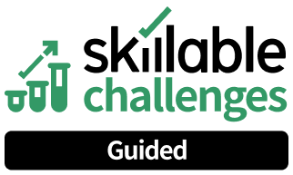

Create a Challenge Lab

**Challenge Overview**

Understand the scenario

You are a New Lab Developer at Skillable, an organization that helps convert current training into challenge centric learning. You will create your first Challenge Lab. First, clone a Challenge Lab template, and then you will create the Title and Overview. Next, you will create 3 sets of Requirements, and then you will create the tasks for each set of Requirements. Next, you will create both Guided and Advanced Hints for the Tasks in Requirement 1, and then you will create a Summary page. Finally, you will add a scoring script to a task in Requirement 1, and then you will launch your new Challenge Lab.

Navigating the Challenge Lab

Unable to process content from https://raw.githubusercontent.com/LODSContent/Challenge-V3- Framework/main/Templates/Environments/None.md

ꀗ Quick tips for navigating the Challenge Lab instructions.

ꀘ Select the Copy to Clipboard icon to copy the green text.

ꀥ Select the Type Text icon to insert the green text directly into the Challenge Lab environment.

ꀖ An Alert tells you that a task requires extra care.

ꀗ A Note provides additional helpful information for completing a task.

ꀉ A Hint will guide you through a portion of the Challenge Lab.

ꀐ A Knowledge block provides a deeper level of knowledge into a subject. It is a great way to solidify your understanding, but it is not strictly necessary to complete the Challenge Lab.

New to Challenge Labs? Click here to learn more.

# Clone the template

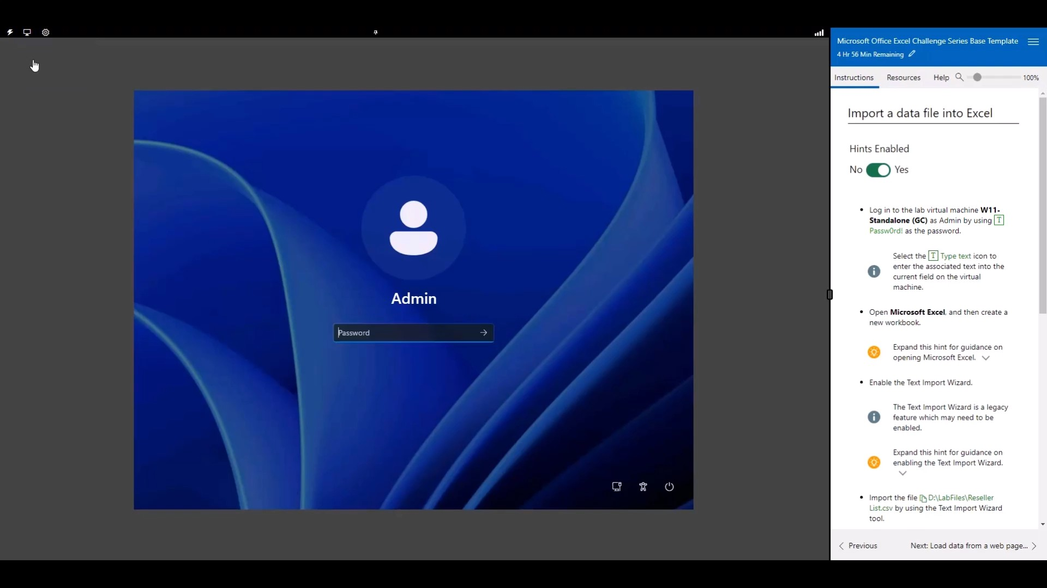

 **Expand this hint for guidance on logging in to a Virtual Machine (VM):**



0:00 / 1:09

## Hints Enabled No Yes



In the following text box, enter the **Email Address** for the account you created in

Skillable Studio:

**Email/Account Name**

In the following text box, enter the **Password** for the user account you created in Skillable Studio:

**Password**

Sign in to  **Win-11** as T Admin by using T Passw0rd! as the password.

 Select the T Type Text icon to enter the associated text into the virtual machine.

Open **Microsoft Edge**, go to T https://labondemand.com/, and then sign as T

<AccountName> by using <Password> as the password.

T

 **Expand this hint for guidance on signing in to Skillable Studio.** 

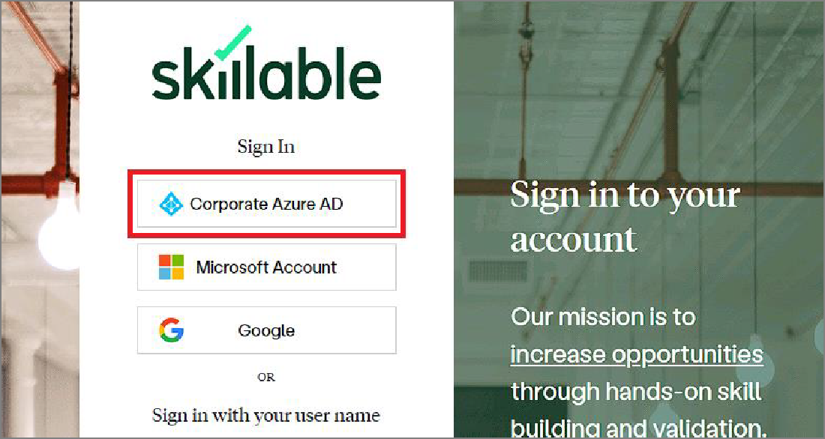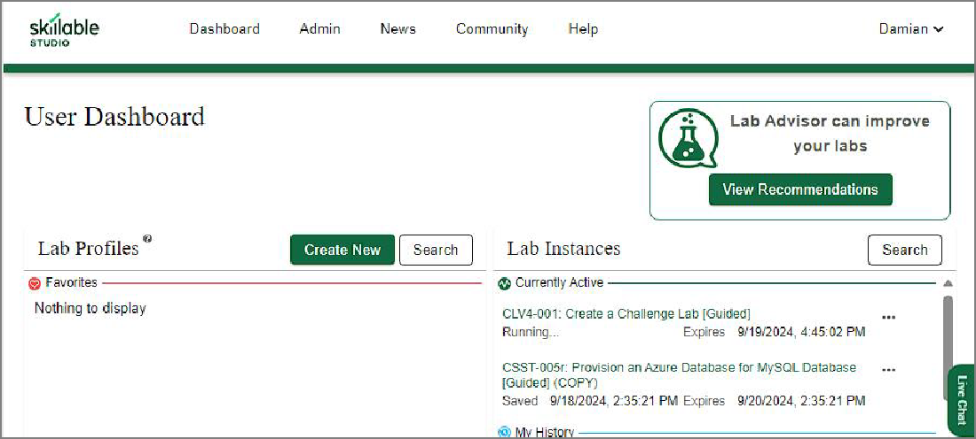

Open Microsoft Edge, and then go to T https://labondemand.com/.

On the Skillable Sign in to your account page, select **Corporate Azure AD**.

On the Microsoft Sign in page, in Email, phone, or Skype, enter T <AccountName>, and then select **Next**.

In Enter password, enter T <Password>, and then select **Sign in**. If asked to Save password, select **Never**.

If asked to Approve sign in request, open your Authenticator app, and then enter the number shown to sign in.

 Want to learn more? Review the documentation on [signing in to Skillable Studio](https://docs.skillable.com/docs/skillable-studio).

Clone the V4-Challenge Lab Template located at T https://labondemand.com/LabProfile/172603 by using details in the following table. For any property that is not specified, use the default value.

|  |  |
| --- | --- |
| **Property** | **Value** |
| Name | T LAB-001 |
| Property 2 | T Configure Threat Intelligence by Using Microsoft Sentinel - Practice Lab [Guided] |
| Series | **Your Sandbox Name** |
| Organization | **Skillable Original Content** |
| Clone this lab | **Enabled** |

 **Expand this hint for guidance on cloning a Challenge Lab.** 

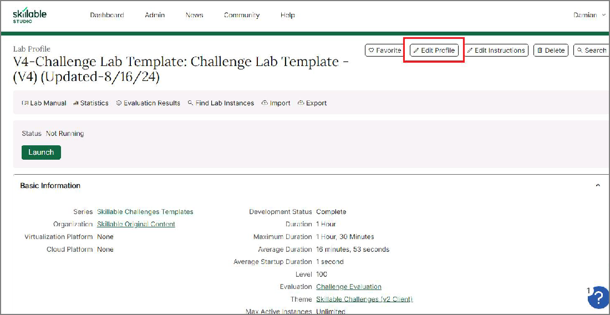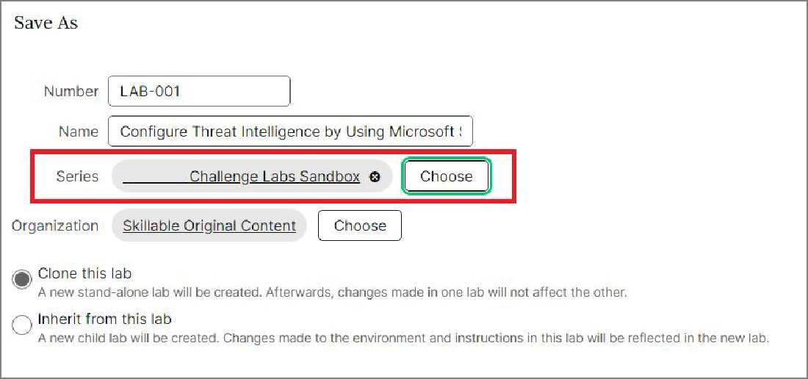

In a new tab, enter T https://labondemand.com/LabProfile/172603, and then press

### Enter.

On the Skillable Studio Lab Profile page, select **Edit profile**.

On the Edit Lab Profile page, on the Basic Information tab, select **Save as**.

On the Save As page, in Number, enter T LAB-001, and then in Name, enter T

Configure Threat Intelligence by Using Microsoft Sentinel - Practice Lab [Guided].

In Series, select **Choose**, and then on the Choose Lab Series, search for and select your personal sandbox, and then select **OK**.

Ensure that Clone this lab is selected, and then select **OK**.

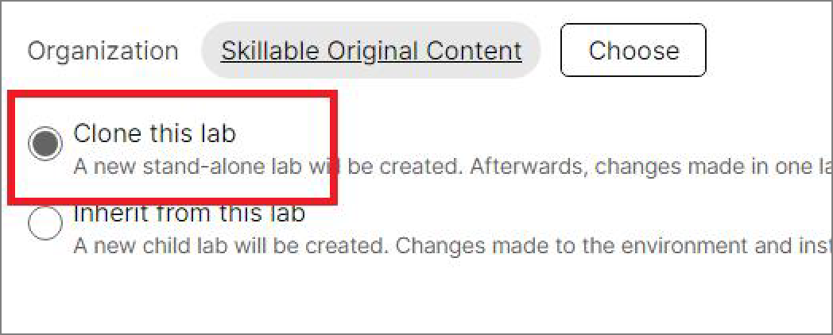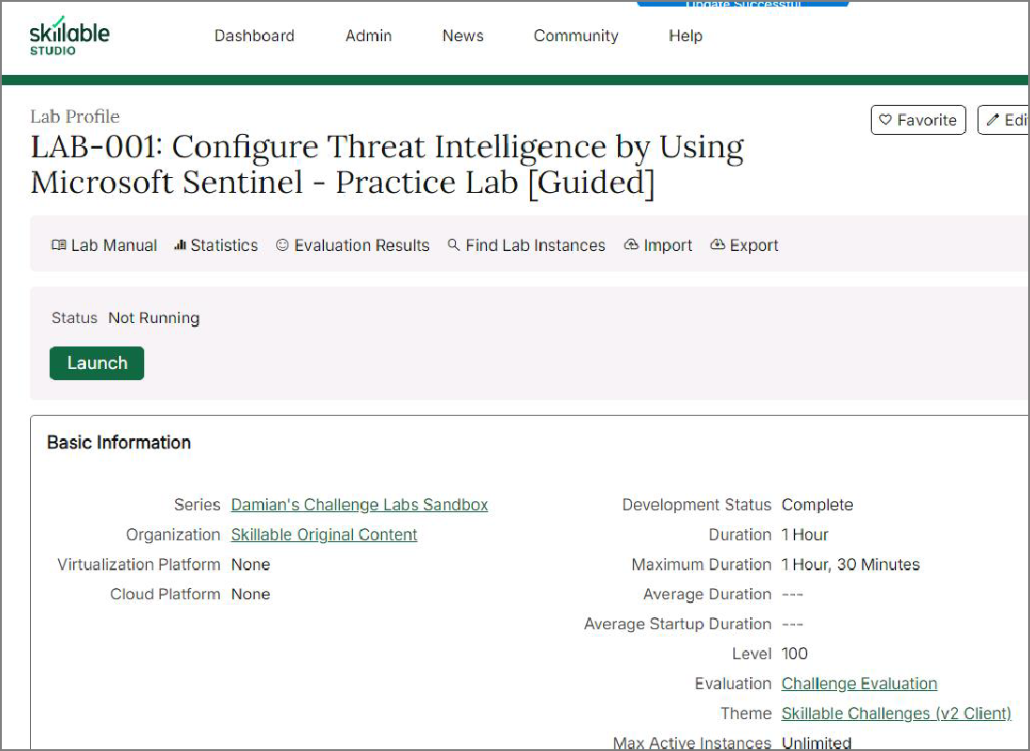

Your cloned Challenge Lab template should look like the following:

 Want to learn more? Review the documentation on [cloning a Challenge Lab](https://docs.microsoft.com/).

 **You MUST clone the template before you begin creating your lab!**

Verify the **Skillable Challenges (v2 Client)** theme, and then add an Optional Note by using the following:

T Changed the theme to Skillable Challenges (v2 Client).

 **Expand this hint for guidance on adding an Optional Note to the V4 theme.** 

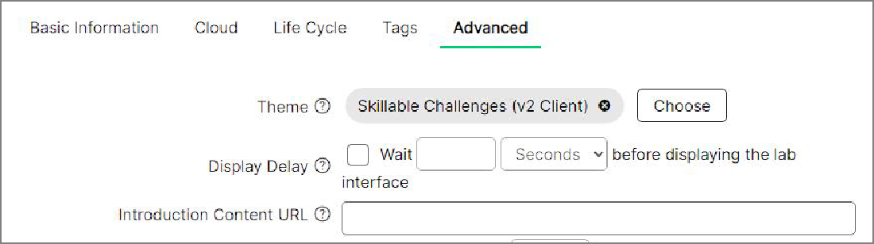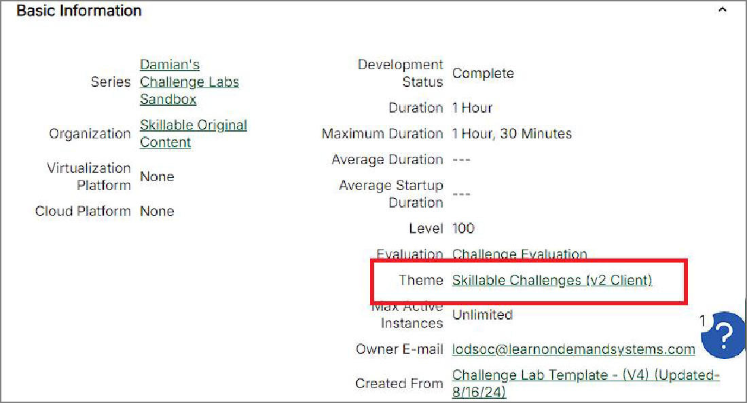

On the **Lab-001** Lab Profile page, select **Edit Profile**.

On the Edit Lab Profile page, on the Advanced tab, verify that the Theme is set to

### Skillable Challenges (v2 Client).

If the Challenge Lab has a different theme, select **Choose**, and then search for and select **Skillable Challenges (v2 Client)**.

Select **Save**

In Note (Optional), enter T Changed the theme to Skillable Challenges (v2 Client), and then select **OK**.

 Want to learn more? Review the documentation on [adding an Optional Note to the V4 theme](https://docs.microsoft.com/).

 If your new Challenge Lab template is already set to Skillable (V2), you may skip this step.

Check your work

Verify

# Create the Title and Overview



## Hints Enabled No Yes

Create the Challenge Lab Title by using the following:

T Configure Threat Intelligence by Using Microsoft Sentinel

 **Expand this hint for guidance on creating a Challenge Lab Title.** 

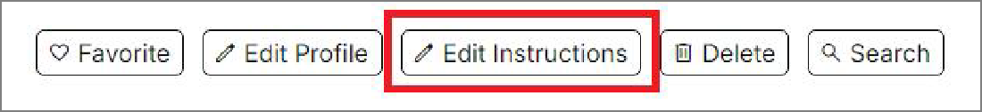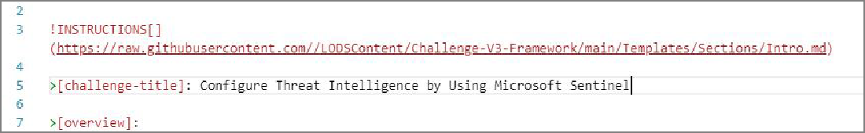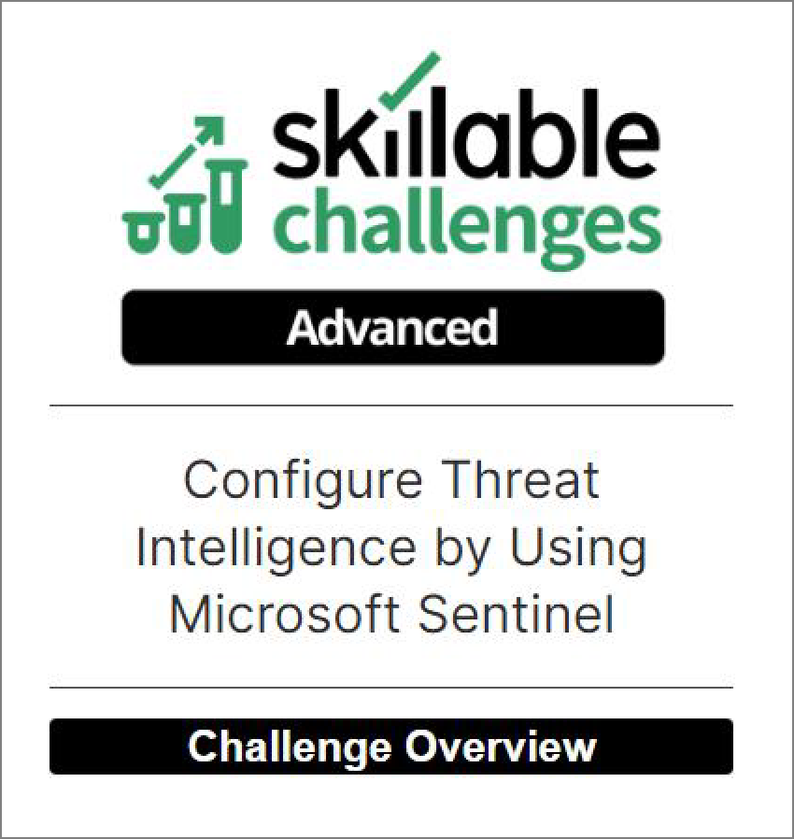

On the **Lab-001** Lab Profile page, select **Edit Instructions**.

In the Markdown editor to the left, on line 5, select **Challenge Title Here**, and then in title case, enter T Configure Threat Intelligence by Using Microsoft Sentinel.

In the Learner Preview window to the right, your Title should look like the following:

 Want to learn more? Review the documentation on [creating a Challenge Lab title](https://portal.document360.io/a298db04-a0fe-47e0-bfe3-c52d6f9d7c8c/document/skillable-internal/view/e6123ed0-532f-469c-a444-08830d24b503).

Create the Challenge Lab Overview by using the following:



You are an <GlobalAnalyst> for Skillable, an organization that needs to train employees on how to use Microsoft Sentinel. First, you will create a new resource group, and then you will create a Log Analytics Workspace and add Microsoft Sentinel to the workspace. Next, you will connect Microsoft Sentinel to Azure Activity, and then you will configure Azure Activity logs to stream to a specified Log Analytics workspace. Next, you will create a remediation task to configure Azure Activity logs to stream to the specified workspace, and then you will connect to Microsoft Sentinel Training Lab data. Finally, you will enable Threat Intelligence, and then you will connect a service to provide your data.

 **Expand this hint for guidance on creating the Challenge Lab Overview.** 

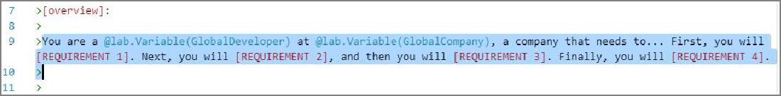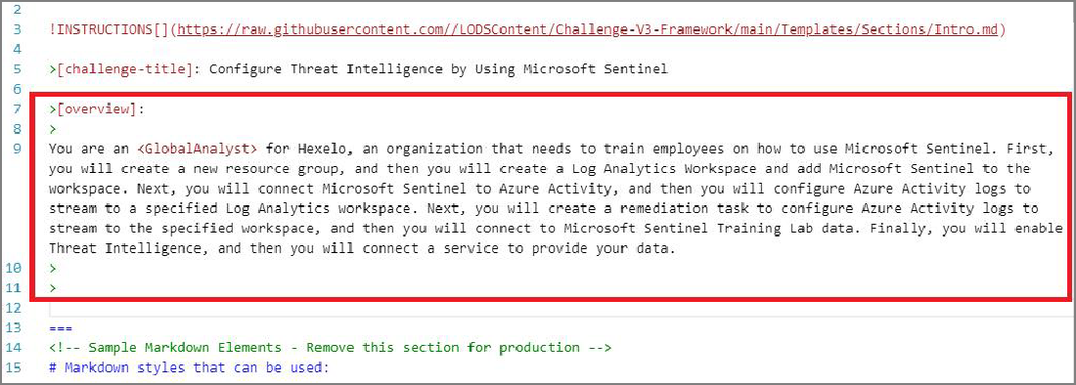

In the Markdown editor, on line 9, select the current Overview placeholder text, and then enter the Overview text from above.

In the Markdown editor to the left, your Overview should look like the following:

In the Learner Preview window to the right, your Overview should look like the following:

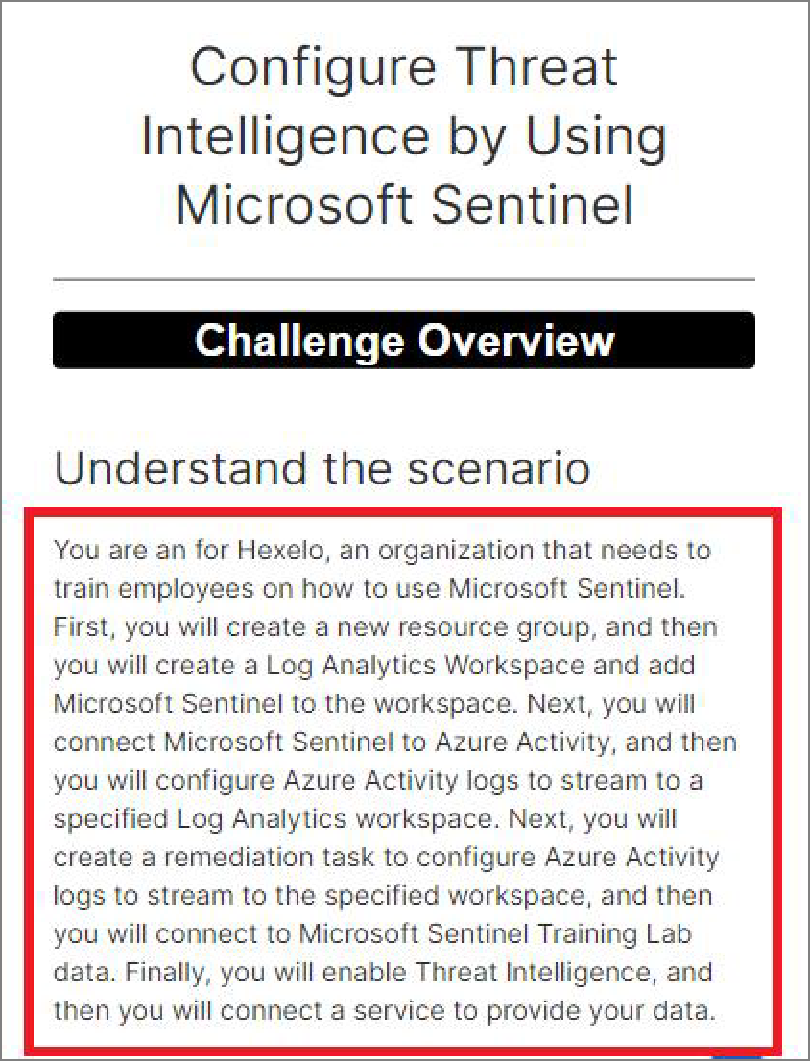

 Want to learn more? Review the documentation on [creating a Challenge Lab title](https://portal.document360.io/a298db04-a0fe-47e0-bfe3-c52d6f9d7c8c/document/skillable-internal/view/e6123ed0-532f-469c-a444-08830d24b503).

 **Notice that on line 9, the** GlobalAnalyst **job role is not appearing in the in the Markdown** 

**editor to the right. This is because we need to add the variable to the** Tokens, Variables, &

Replacements **section.**

 **Variables** 

Create the Job Role.

 **Expand this hint for guidance on creating the Job Role.** 

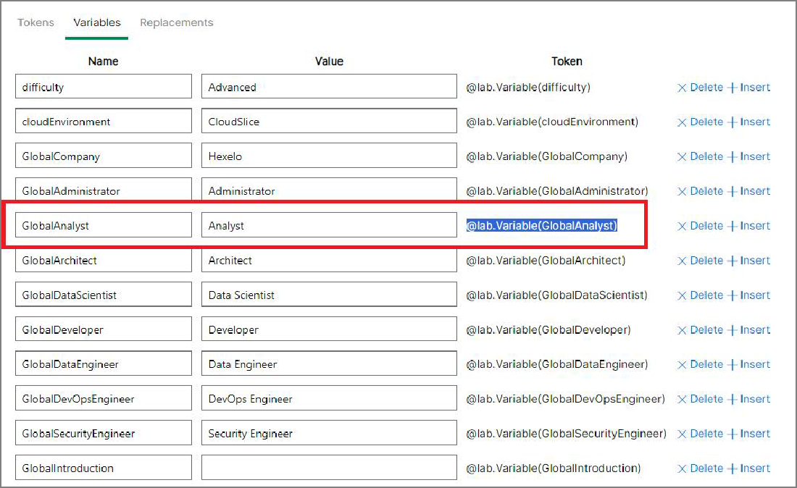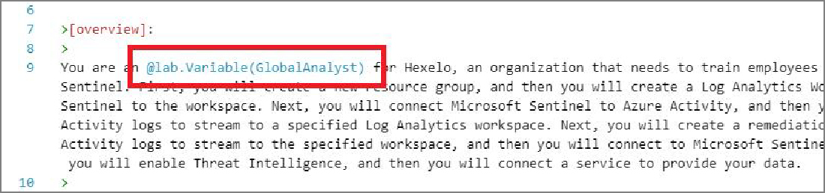

In the Markdown editor, on the Menu bar at the top of the screen, select the **@lab**

icon.

In the @lab options window, select the Variables tab, and then in Token, select and copy the **<GlobalAnalyst>** token, and then select **OK**.

In the Markdown editor, on line 9, select the job role, and then replace it with the Token you just copied.

In the Learner Preview window to the right, your Overview should look like the following:

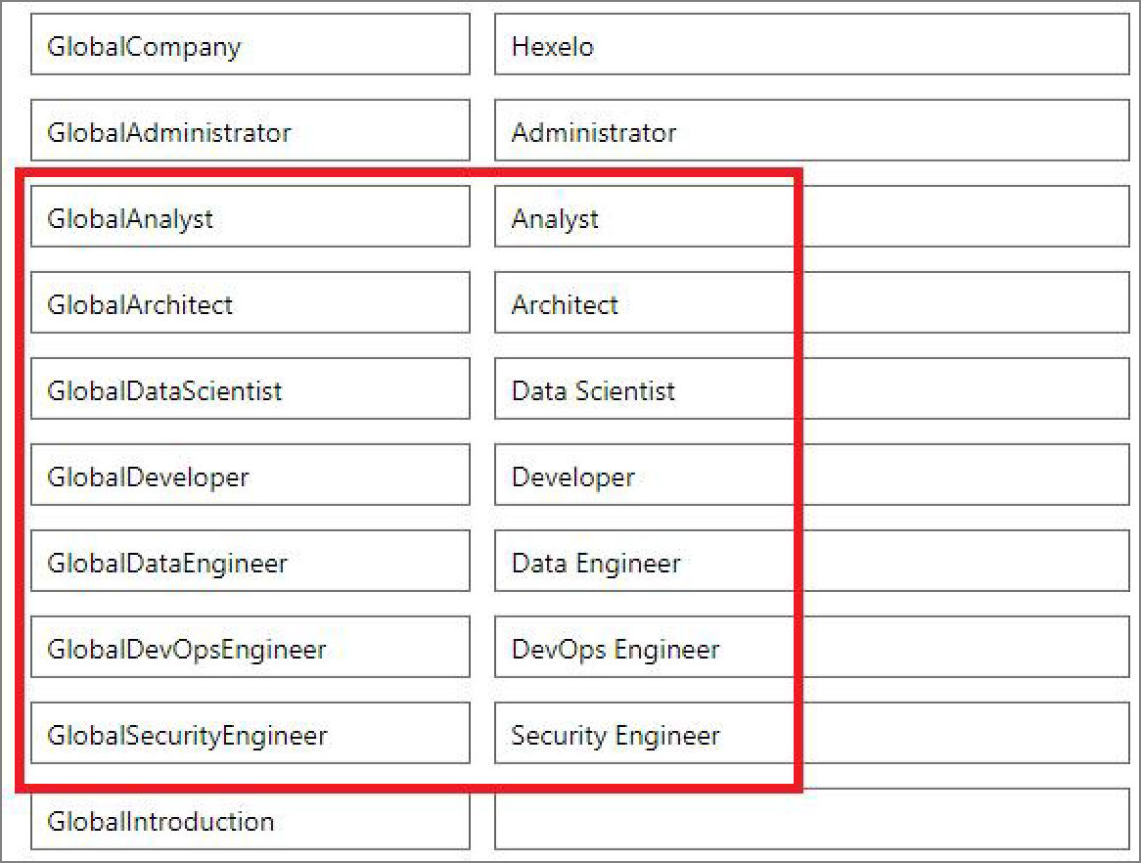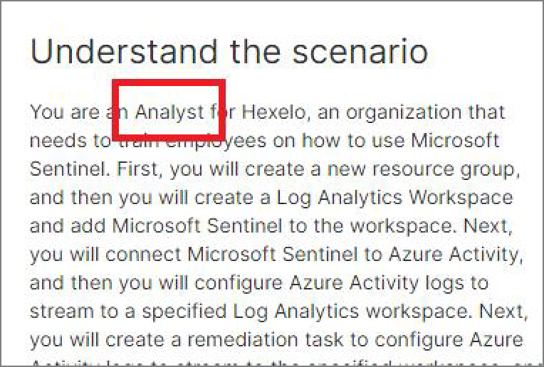

Notice that the **Analyst** job role now appears in the Learner Preview window.

 There are several other job roles to choose from, however, for the prupose of this lab, we have chosen the Analyst job role.

Want to learn more? Review the documentation on [creating the Job Role](https://portal.document360.io/a298db04-a0fe-47e0-bfe3-c52d6f9d7c8c/document/skillable-internal/view/f53827c1-8c56-4a4b-96df-8ac8786421ce).

Change the Company name from Hexelo to T New Company.

 **Expand this hint for guidance on changing the Company name.** 

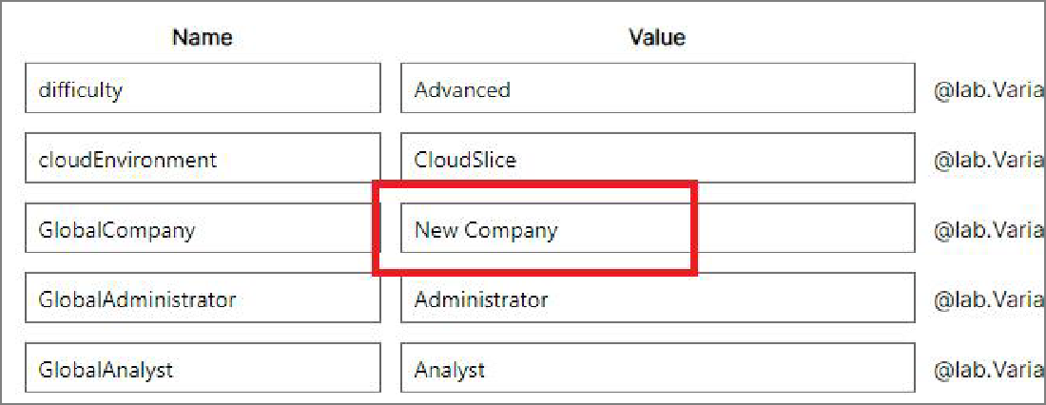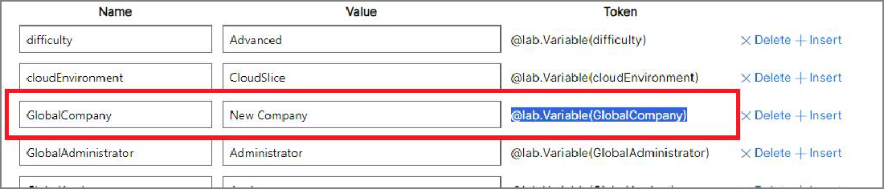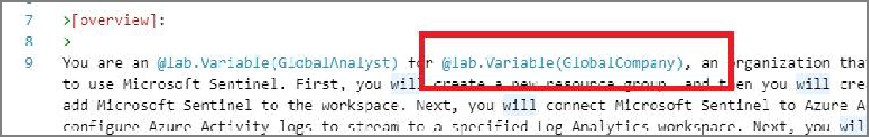

In the Markdown editor, on the Menu bar at the top of the screen, select the **@lab**

icon.

In the @lab options window, select the Variables tab, and then in Name, locate

### GlobalCompany.

In Value, select **Hexelo**, and then enter T New Company.

In Token, select and copy the **Skillable** token, and then select **OK**.

In the Markdown editor, on line 9, select **Hexelo**, and then replace it with the Token you just copied.

Notice that the Company name has been updated to display **New Company** as the new company name.

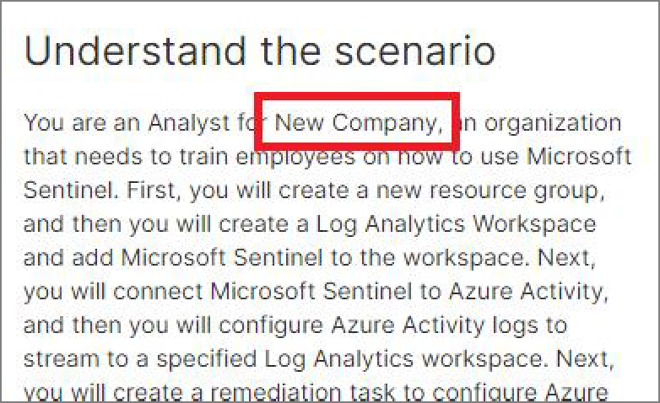

 Want to learn more? Review the documentation on [changing the Company name](https://portal.document360.io/a298db04-a0fe-47e0-bfe3-c52d6f9d7c8c/document/skillable-internal/view/f53827c1-8c56-4a4b-96df-8ac8786421ce).

Change the Challenge Lab from Advanced to T Guided.

 **Expand this hint for guidance on changing the lab difficulty level.** 

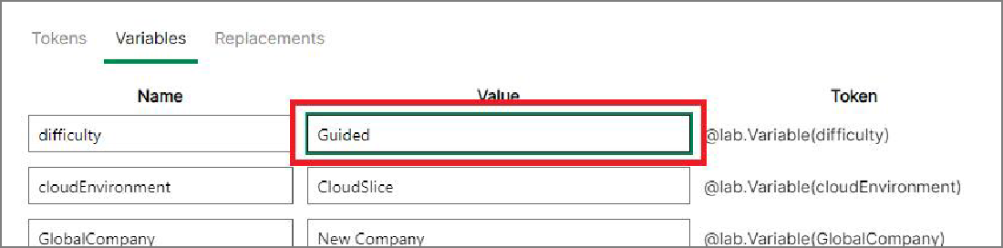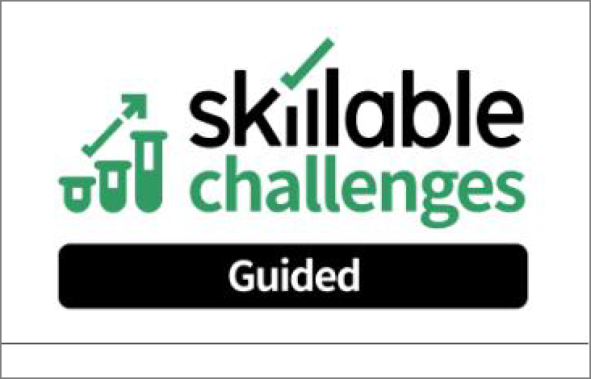

In the Markdown editor, on the Menu bar at the top of the screen, select the **@lab**

icon.

In the @lab options window, select the Variables tab, and then in Name, locate

### difficulty.

In Value, select **Advanced**, enter T Guided, and then select **OK**.

Notice that the Challenge Lab logo has been updated to display the Guided logo.

 Want to learn more? Review the documentation on [changing the lab difficulty level](https://portal.document360.io/a298db04-a0fe-47e0-bfe3-c52d6f9d7c8c/document/skillable-internal/view/67a15361-4d14-41af-a840-83fe22ebc447).

Check your work

Verify

# Create the Requirements



## Hints Enabled No Yes

Create a Requirement named T # Add Microsoft Sentinel to a workspace.

 **Expand this hint for guidance on creating a new Requirement.** 

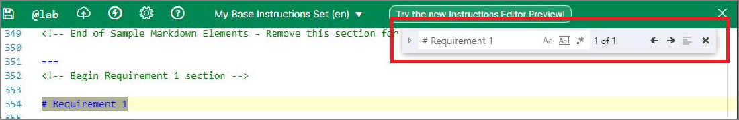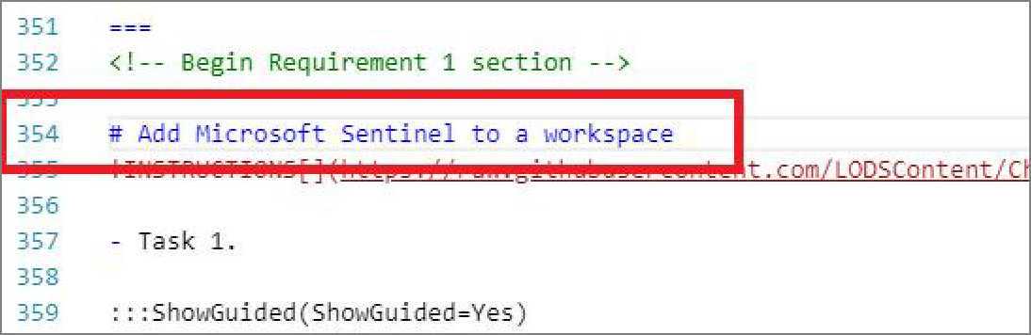

Press **Ctrl+F** to open the **Find** dialog, and then enter T # Requirement 1.

In the Markdown editor, on line #354, select **# Requirement 1**, and then enter T # Add Microsoft Sentinel to a workspace.

In the Learner Preview window, select **Next**, and then on the Markdown styles that can be used page, select **Next** again.

In the Variables window, select **Next**, and then notice that Requirement 1 now displays

### Add Microsoft Sentinel to a workspace.

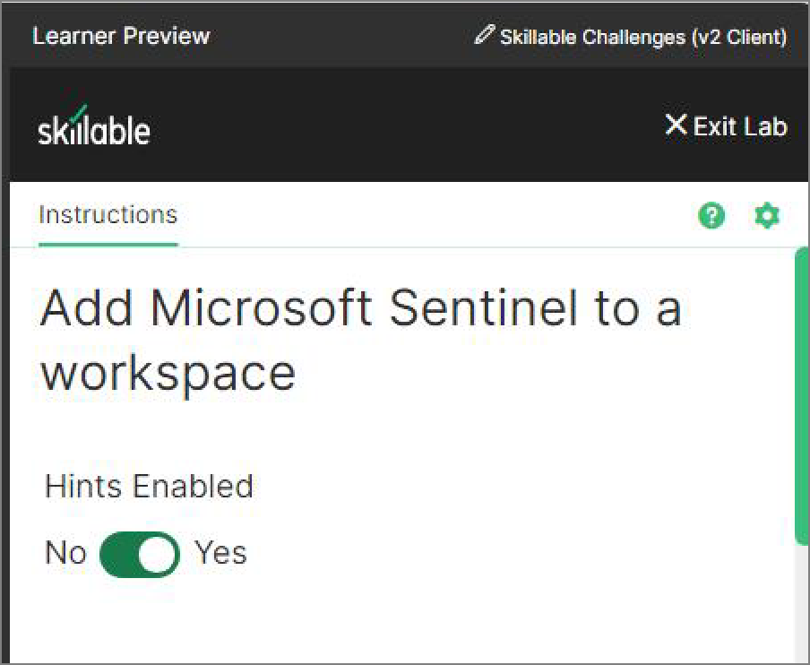

 Want to learn more? Review the documentation on [creating a new Requirement](https://portal.document360.io/a298db04-a0fe-47e0-bfe3-c52d6f9d7c8c/document/skillable-internal/view/b6c7f9e8-8f46-47bd-ab84-da4011e8ac9c). Click here for more information.

Create a second Requirement named T # Enable a Data Connector.

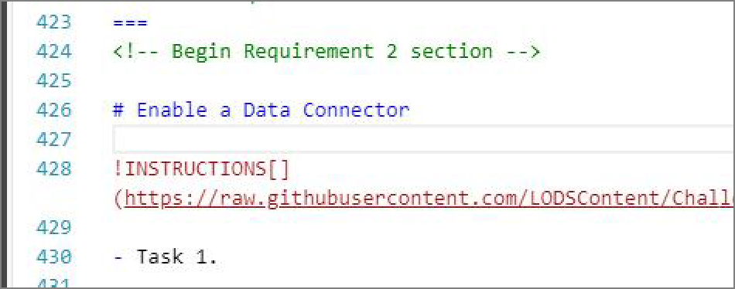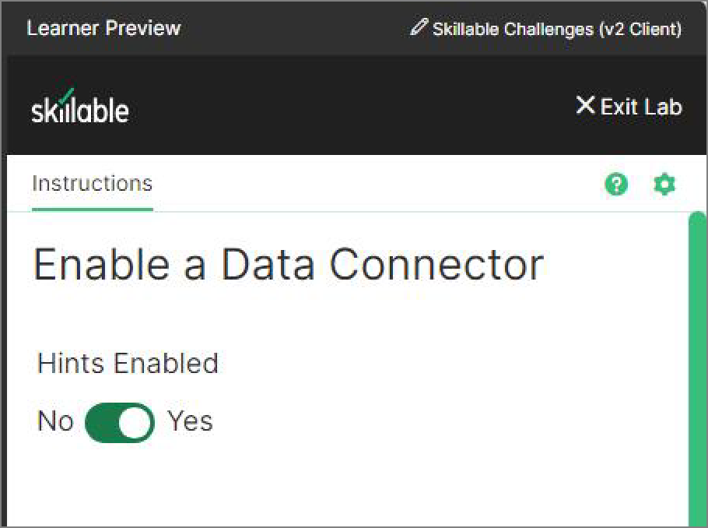

 **Expand this hint for guidance on creating a new Requirement.**



In the **Find** dialog, enter T # Requirement 2.

In the Markdown editor, select **# Requirement 2**, and then enter T # Enable a Data Connector.

In the Learner Preview window, select **Next**, and then notice that Requirement 2 now displays **Enable a Data Connector**.

Create a third Requirement named T # Enable Threat Intelligence.

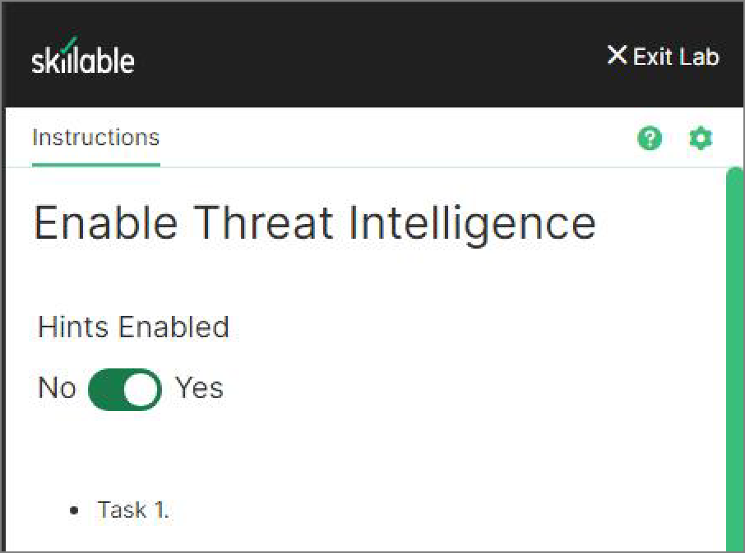

 **Expand this hint for guidance on creating a new Requirement.**



In the **Find** dialog, enter T # Requirement 3.

In the Markdown editor, select **# Requirement 3**, and then enter T # Enable Threat Intelligence.

In the Learner Preview window, select **Next**, and then notice that Requirement 3 now displays **Enable Threat Intelligence**.

Remove the remaining Requirement sections from the template.

 **Expand this hint for guidance on removing the remaining Requirement sections.** 

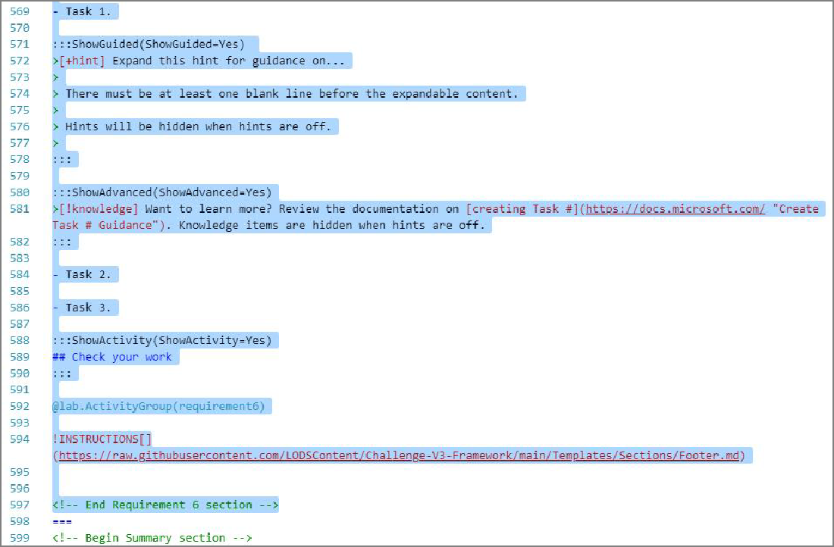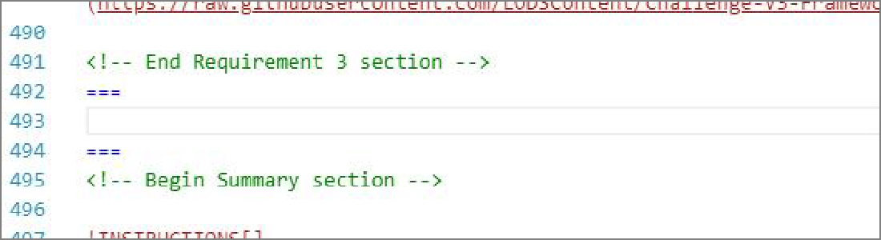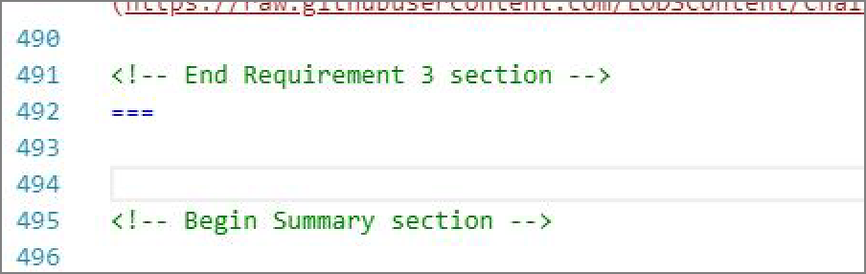

In the **Find** dialog, enter T Begin Requirement 4 section.

In the Markdown editor select the line that says **!-- Begin Requirement 4 section --**, hold down shift, scroll down to **!--End Requirement 6 section--**, and then press **Delete**.

In the Markdown editor, your template should look like the following:

Select either set of **===**, and then press **Delete**.

Verify

In the Learner Preview window, select **Next**, and then verify that you are on the

**Summary** page.

Check your work

# Create the tasks for Requirement 1



## Hints Enabled No Yes

On the **Clone the template** requirement page, create a task instructing learners to sign in to

T Win-11 as T Admin by using T Passw0rd! as the password.

 **Expand this hint for guidance on creating a new Task.** 

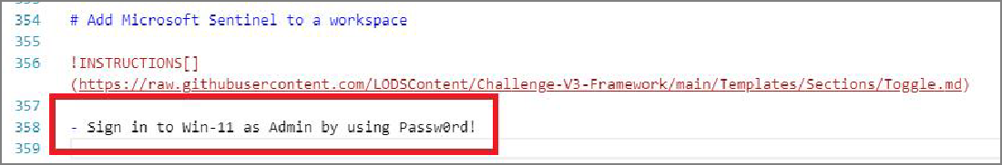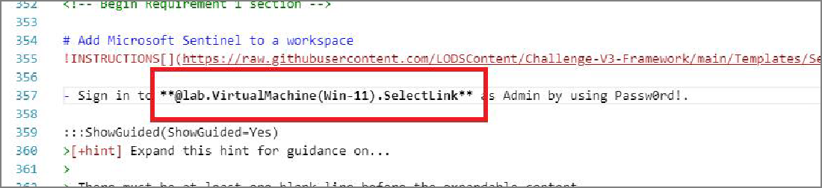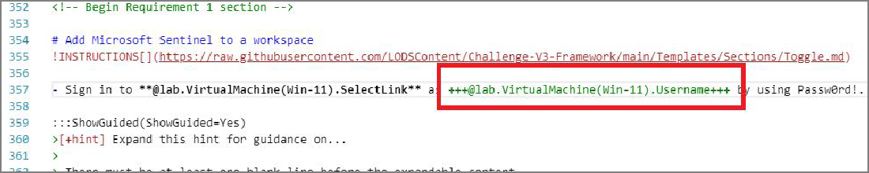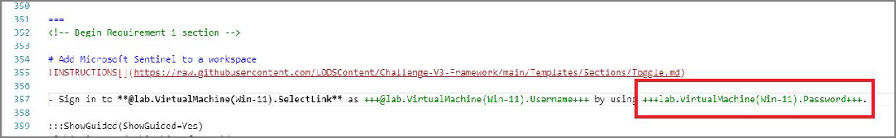

In the **Find** dialog, enter T # Add Microsoft Sentinel to a workspace.

Just below the **!INSTRUCTIONS []** github include link, select **- Task 1.**, and then enter

T - Sign in to Win-11 as Admin by using Passw0rd!.

Select **Win-11**, and then replace it with T lab.VirtualMachine(Win-11).SelectLink. Insert T @ directly in front of **lab.VirtualMachine(Win-11).SelectLink**.

Select **Admin**, and then replace it with T lab.VirtualMachine(Win-11).Username. Insert T @ directly in front of **lab.VirtualMachine(Win-11).Username**.

Insert 3 plus signs directly in front of the **@** symbol, and then add another 3 plus signs directly after **Username**, to convert the string to TypeText.

Select **Passw0rd!**, and then replace it with T lab.VirtualMachine(Win-11).Password. Insert T @ directly in front of **lab.VirtualMachine(Win-11).Password**.

Insert 3 plus signs directly in front of the **@** symbol, and then add another 3 plus signs directly after **Password**, to convert the string to TypeText.

Your completed Task 1 should look like the following:

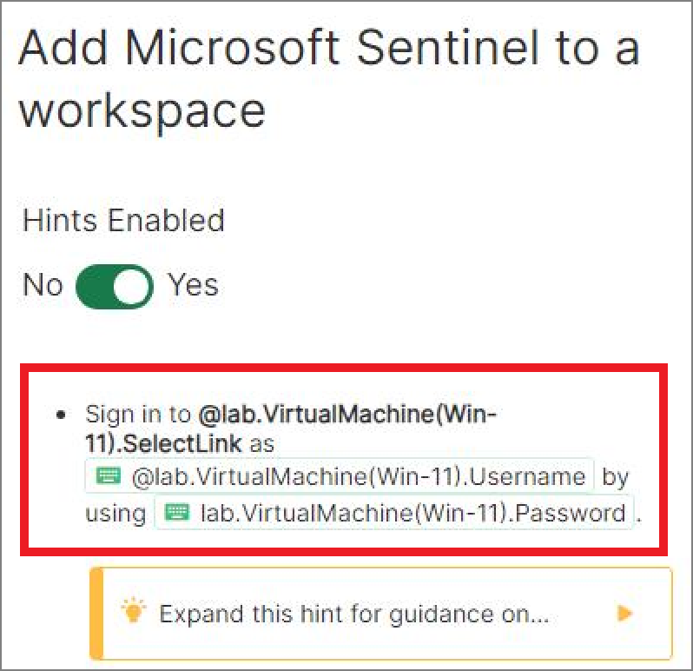

 Want to learn more? Review the documentation on [creating a new Task](https://portal.document360.io/a298db04-a0fe-47e0-bfe3-c52d6f9d7c8c/document/skillable-internal/view/b6c7f9e8-8f46-47bd-ab84-da4011e8ac9c). Click here for more information.

Create a second task instructing learners to navigate to T https://portal.azure.com, signing in as T {USERNAME} by using T {PASSWORD} as the password.

 **Expand this hint for guidance on creating a new Task.** 

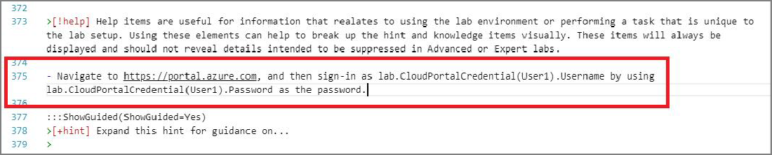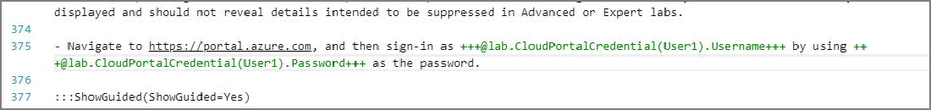

In the **Find** dialog, enter T Task 2.

Select **- Task 2.**, and then enter T - Navigate to **https://portal.azure.com**, and then sign-in as **lab.CloudPortalCredential(User1).Username** by using **lab.CloudPortalCredential(User1).Password** as the password.

Insert T @ directly in front of **lab.CloudPortalCredential(User1).Username**, and then insert T @ directly in front of **lab.CloudPortalCredential(User1).Password**.

Insert 3 plus signs directly in front of each **@** symbol, and then add another 3 plus signs directly after **Username** and **Password**, to convert the string to TypeText.

Your completed Task 2 should look like the following:

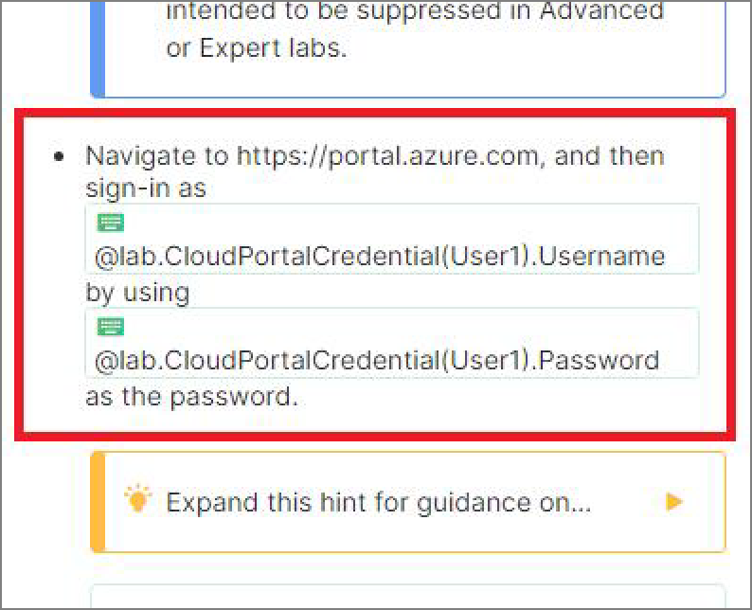

Create a third task instructing learners to create a new resource group named T

SentinelHexelo-RG in the **East US region**.

 **Expand this hint for guidance on creating a new Task.** 

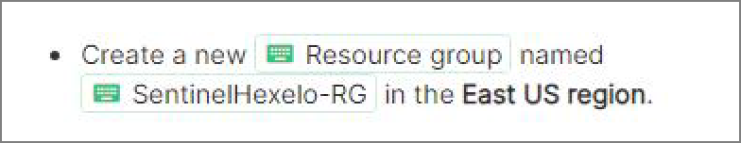

In the **Find** dialog, enter T Task 3.

Select **- Task 3.**, and then enter T - Create a new Resource group named

### SentinelHexelo-RG in the East US region.

Insert 3 plus signs directly before and after **Resource group**, and then add another 3 plus signs directly before and after **SentinelHexelo-RG** to convert the string to TypeText.

Insert 2 astericks directly before and after **East US region** to change the text to bold.

Your completed Task 3 should look like the following:

Create a fourth task instructing learners to create a T Log Analytics Workspace named T

SentinelHexelo-LAW in the **SentinelHexelo** resource group, by using **East US** as the Region.

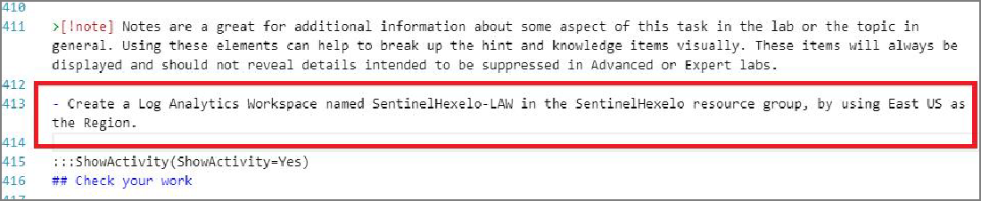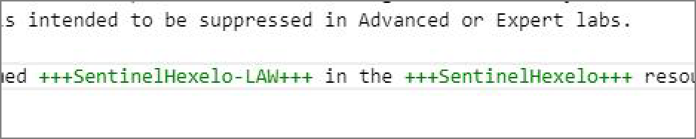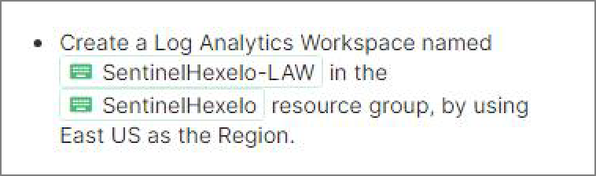

 **Expand this hint for guidance on creating a new Task.**



In the **Find** dialog, enter T ShowActivity(ShowActivity=Yes).

On the line directly above the ShowActivity variable, type T - Create a Log Analytics Workspace named SentinelHexelo-LAW in the SentinelHexelo resource group, by using East US as the Region., and then press **Enter** 2 times.

Convert **Log Analytics Workspace** to TypeText, and then convert **SentinelHexelo- LAW** to TypeText.

Format **East US region** to bold text.

Your completed Task 4 should look like the following:

Create a fifth task instructing learners to add T Microsoft Sentinel to the **SentinelHexelo-LAW**

workspace.

 **Expand this hint for guidance on creating a new Task.** 

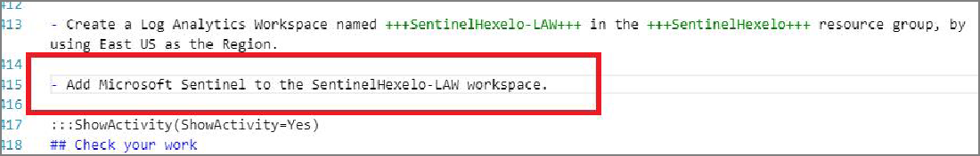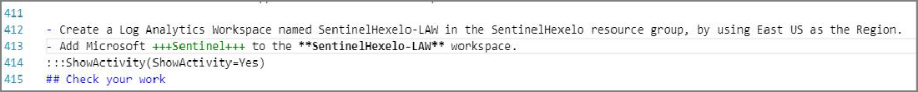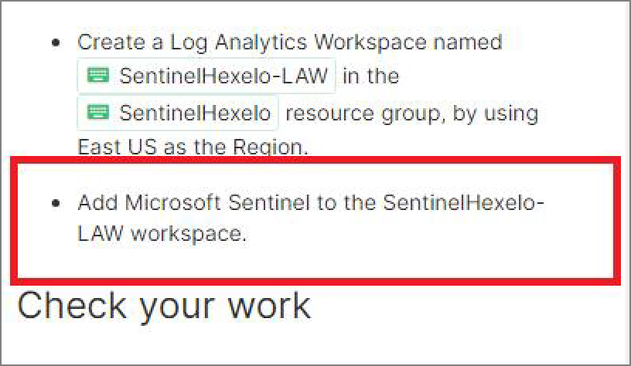

Directly below Task 4, on a new line, enter T - Add Microsoft Sentinel to the SentinelHexelo-LAW workspace.

Convert **Microsoft Sentinel** to TypeText. Format **SentinelHexelo-LAW** to bold text.

Verify there is a space between Task #4 and Task #5.

Your completed Task 5 should look like the following:

Check your work

Verify

# Create the tasks for Requirement 2

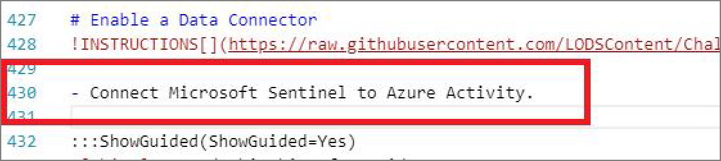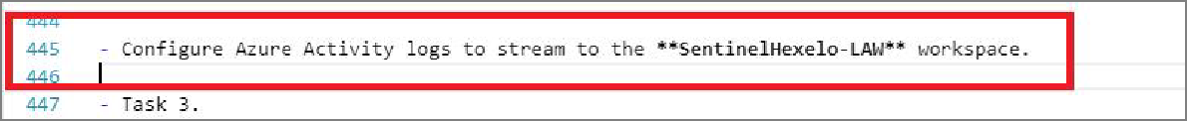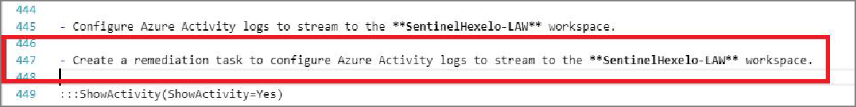

## Hints Enabled No Yes

On the **Enable a Data Connector** requirement page, create a task instructing learners to T

Connect Microsoft Sentinel to Azure Activity.

On the **Enable a Data Connector** requirement page, create a second task instructing learners to T Configure Azure Activity logs to stream to the SentinelHexelo-LAW workspace, and then add a bold format to **SentinelHexelo-LAW**.

On the **Enable a Data Connector** requirement page, create a third task instructing learners to T Create a remediation task to configure Azure Activity logs to stream to the SentinelHexelo- LAW workspace, and then add a bold format to **SentinelHexelo-LAW**.

The finished Enable a Data Connector requirement page should look like the following:

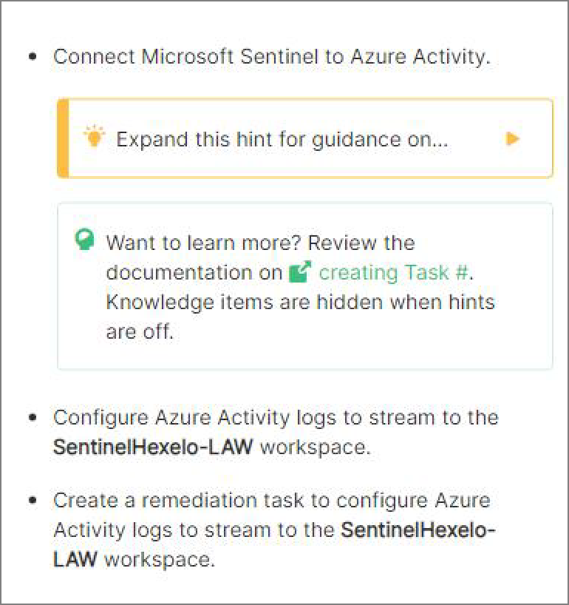

Verify

Check your work

# Create the tasks for Requirement 3

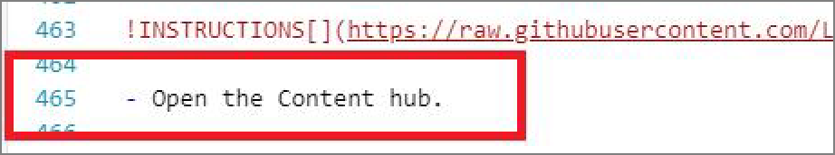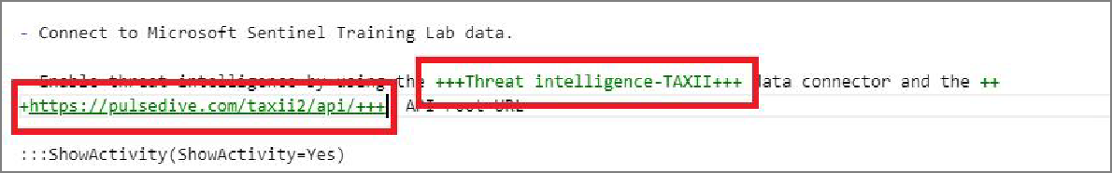

## Hints Enabled No Yes

On the **Enable Threat Intelligence** requirement page, create a task instructing learners to T

Open the content hub.

On the **Enable Threat Intelligence** requirement page, create a second task instructing learners to T Connect to Microsoft Sentinel Training Lab data.

On the **Enable Threat Intelligence** requirement page, create a third task instructing learners to T Enable threat intelligence by using the **Threat intelligence-TAXII** data connector and the **https://pulsedive.com/taxii2/api/** API root URL, and then press **Enter** twice:

In the Task 3 which you just created, convert **Threat intelligence-TAXII** and

**https://pulsedive.com/taxii2/api/** to TypeText.

On the **Enable Threat Intelligence** requirement page, create a fourth task instructing learners to T - Navigate to https://pulsedive.com/, and then connect a service to provide your TAXII data. Use the values in the following table to register an account., and then press **Enter** twice.

In Task #4, convert **https://pulsedive.com/** to TypeText.



| **Property** | **Value** |

|:---------| |

| **Email**

| **Username**

| **Password**

| **Your Email**

|

| ++**User1**{LAB_INSTANCE_ID}++ |

| ++PA{PASSWORD}++ |

| **Job Title** | ++**Administrator**++ |

| **Company or Organization** | ++**Hexelo**++ |

Add a table to Task #4 containing the following information:



 **Expand this hint for guidance on creating a table.** 

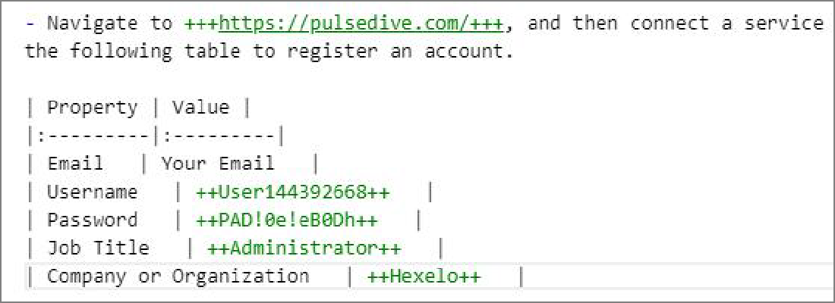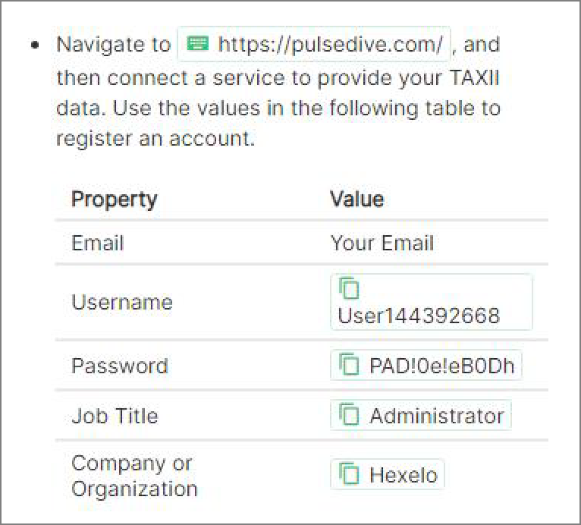

Directly below Task #4, enter the following:

 | **Property** | **Value** |

|:---------| |

| **Email** | **Your Email** |

| **Username** | ++**User1**{LAB_INSTANCE_ID}++ |

| **Password** | ++PA{PASSWORD}++ |

| **Job Title** | ++**Administrator**++ |

| **Company or Organization** | ++**Hexelo**++ |

Your completed table markdown should look like the following:

Select the entire table markdown, and then press **Tab** to indent the markdown to display inline with the Task in the Learner Preview window.

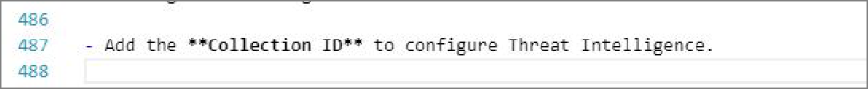

 Want to learn more? Review the documentation on [creating a table](https://portal.document360.io/a298db04-a0fe-47e0-bfe3-c52d6f9d7c8c/document/skillable-internal/view/b6c7f9e8-8f46-47bd-ab84-da4011e8ac9c). Click here for more information.

 To indent the table, preceed it with a bulleted item, then indent the table itself. There must be a blank line following the bullet before the table.

On the **Enable Threat Intelligence** requirement page, create a fourth task instructing learners to T - Add the **Collection ID** to configure Threat Intelligence, and then covert the **Collection ID** text to TypeText.

On the **Enable Threat Intelligence** requirement page, create a fifth task instructing learners to T Add the **API key** as the Password to configure Threat Intelligence, and then apply a bold format to the **API key** text.

The finished Enable Threat Intelligence requirement page should look like the following:

Check your work

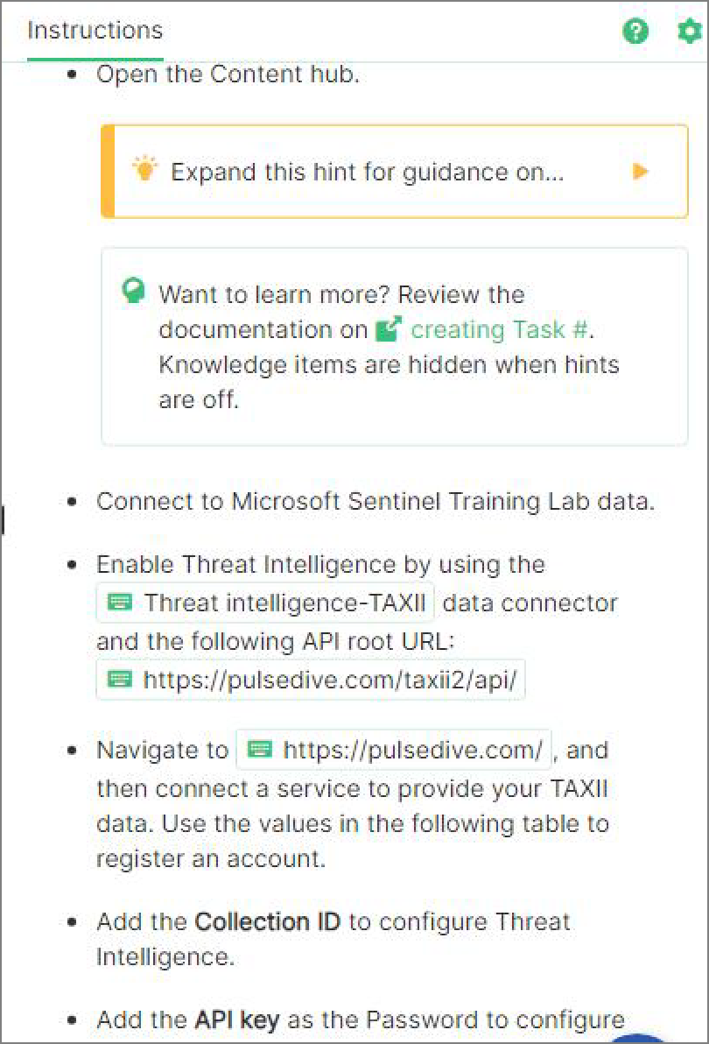

Verify

# Create Guided and Advanced Hints for the Tasks in Requirement 1



## Hints Enabled No Yes

Create a Guided Hint for the first task of Requirement 1, by using the following:



:::**ShowGuided**(**ShowGuided**=**Yes**)

>[+hint] **Expand this** hint **for** guidance on logging **in** to a **Virtual Machine**

>

> !video[**Logging in** to a **Virtual Machine** (VM)](https:*//lodmanuals.blob.c*

:::

 

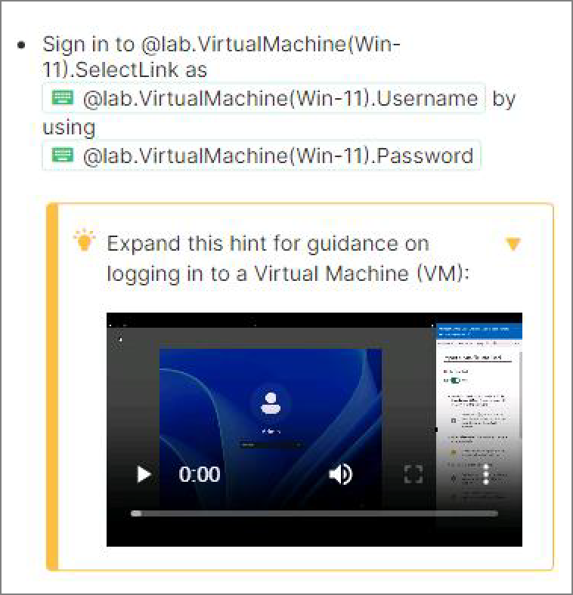

 **Expand this hint for guidance on creating a guided hint.**



In Requirement #1, locate Task #1, select the Guided Hint placeholder, and then press

**Delete**.

Enter the Guided Hint text from above.

In the Learner Preview window, expand the Guided Hint icon, and then verify that the Task #1 Guided Hint looks like the following:

 Want to learn more? Review the documentation on [creating a guided hint](https://portal.document360.io/a298db04-a0fe-47e0-bfe3-c52d6f9d7c8c/document/skillable-internal/view/cdaef350-fb61-4bf0-9516-5d361d98058e/).

 **There must be at least one blank line before the expandable content.** 

Create a Guided Hint for the second task of Requirement 1, by using the following:



:::**ShowGuided**(**ShowGuided**=**Yes**)

>[+hint] **Expand this** hint **for** guidance on signing **in** to the **Azure** portal.

>

>- **Open** a **new** browser tab, **and then** go to +++https:*//portal.azure.com+++.*

>

>- **Sign in as** +++{USERNAME}+++ **by using** +++{PASSWORD}+++ **as** the password.

>

>- **If** asked to save the password, **select** \*\***Never**\*\*.

>

>- **If** asked to **Stay signed in**, **select** \*\***No**\*\*.

>

>- **Close** any **Welcome** pages.

:::

 

 **Expand this hint for guidance on creating a guided hint.** 

In Requirement #1, locate Task #2, select the Guided Hint placeholder, and then press

### Delete.

Enter the Guided Hint text from above.

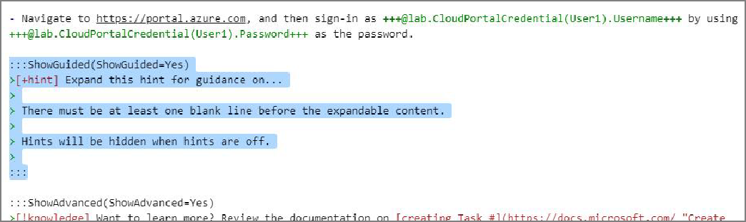

In the Learner Preview window, expand the Guided Hint icon, and then verify that the Task #2 Guided Hint looks like the following:

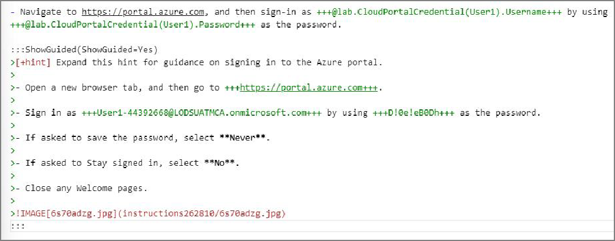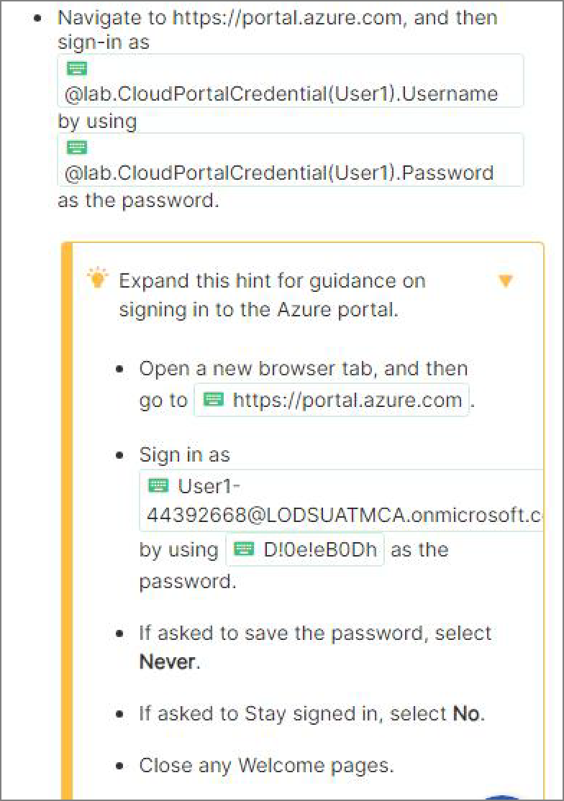

Create the Advanced Hint for the second Task of Requirement 1.



:::**ShowAdvanced**(**ShowAdvanced**=**Yes**)

>[!knowledge] **Want** to learn more? **Review** the documentation on [signing **in**

:::

 

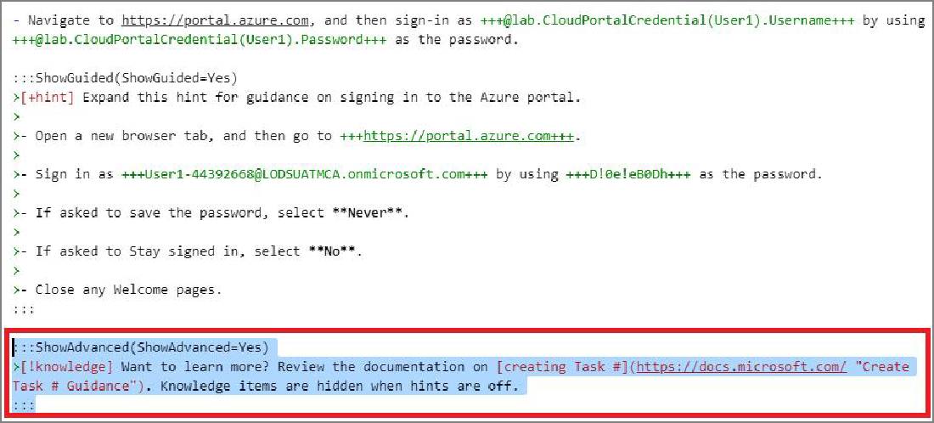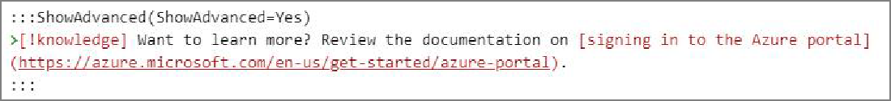

 **Expand this hint for guidance on creating an advanced hint.** 

In Requirement #1, locate the Task #2 Guided Hint, select the **Advanced** Hint placeholder just below it, and then press **Delete**.

Enter the Advanced Hint text from above.

In the Learner Preview window, review the Advanced Hint, and then verify that the Task #2 Advanced Hint looks like the following:

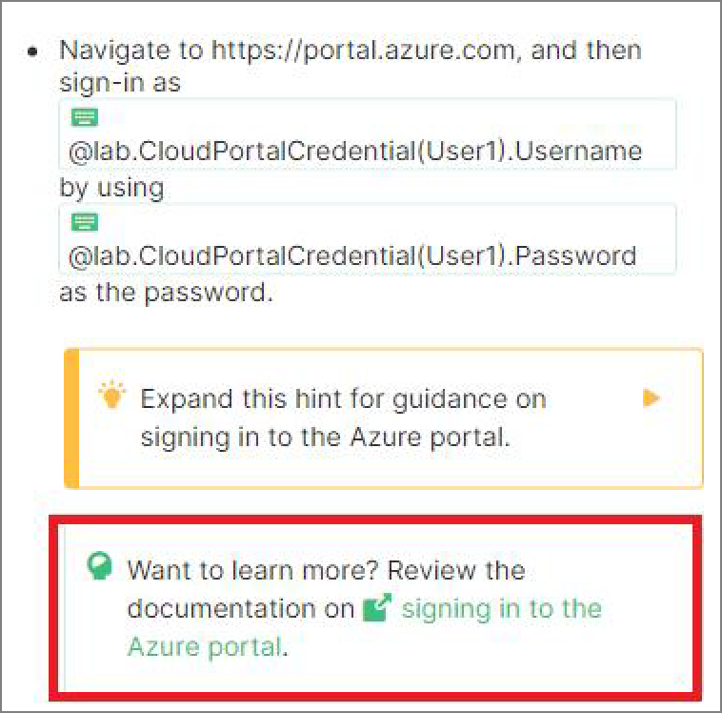

 Want to learn more? Review the documentation on [creating an advanced hint](https://portal.document360.io/a298db04-a0fe-47e0-bfe3-c52d6f9d7c8c/document/skillable-internal/view/cdaef350-fb61-4bf0-9516-5d361d98058e/).

 **If there is enough content, a Knowledge block will automatically be expandable.** 

Create a Guided Hint for the third task of Requirement 1, by using the following:



:::**ShowGuided**(**ShowGuided**=**Yes**)

>[+hint] **Expand this** hint **for** guidance on creating a **Resource group**.

>

>- **On** the **Microsoft Azure** home page, **in Search** resources, services, **and** d

>

>- **On** the **Resource** groups page, **select** \*\***Create**\*\*.

>

>- **On** the **Create** a resource **group** page, **select** your **Subscription**, **and the**

>

>- **In Region**, **select East** US, **and then select** \*\***Review** + create**.

>

>- **On** the **Review** + create tab, verify that the resource **group** has passed

:::

 

 **Expand this hint for guidance on creating a guided hint.** 

In Requirement #1, locate Task #3, select the Guided Hint placeholder, and then press

### Delete.

Enter the Guided Hint text from above.

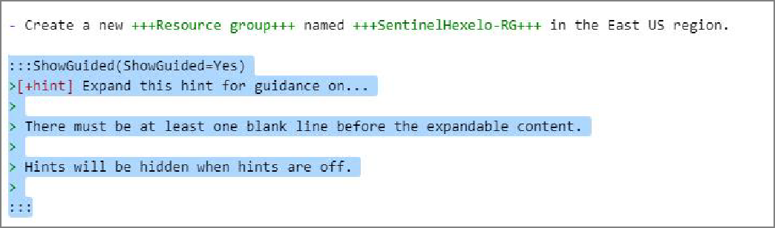

In the Learner Preview window, expand the Guided Hint icon, and then verify that the Task #3 Guided Hint looks like the following:

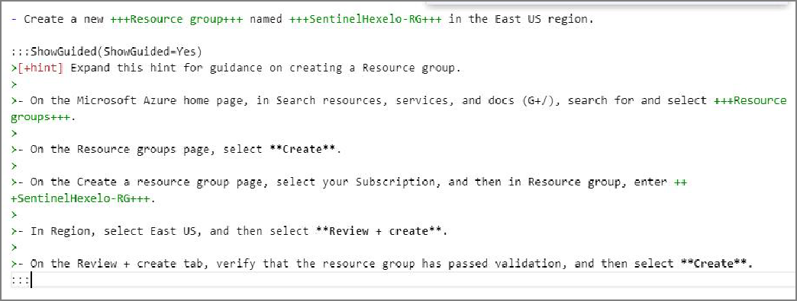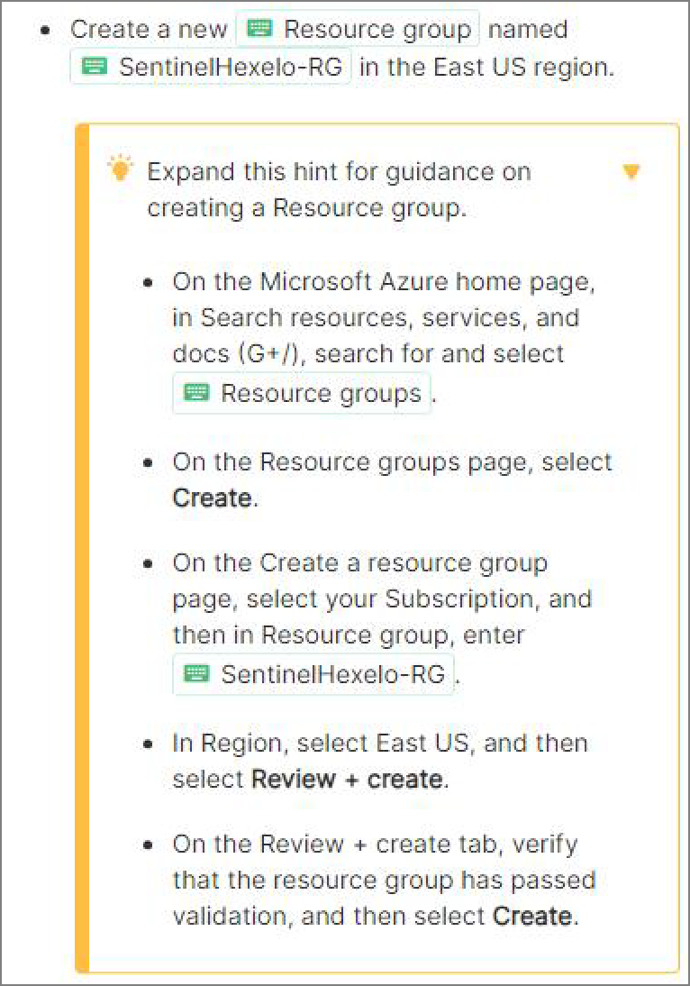

Create the Advanced Hint for the third Task of Requirement 1.



:::**ShowAdvanced**(**ShowAdvanced**=**Yes**)

>[!knowledge] **Want** to learn more? **Review** the documentation on [creating a

:::

 

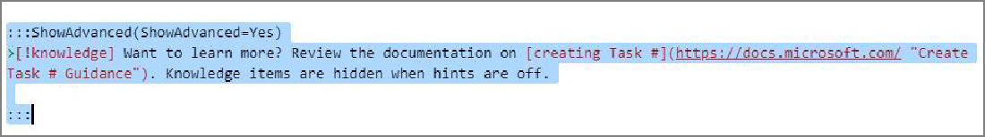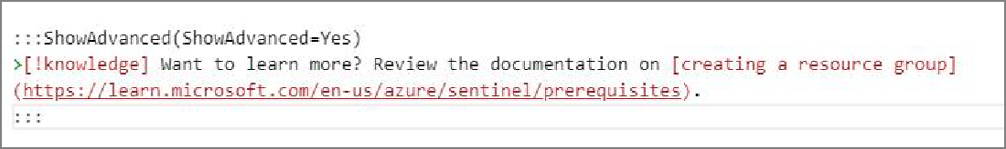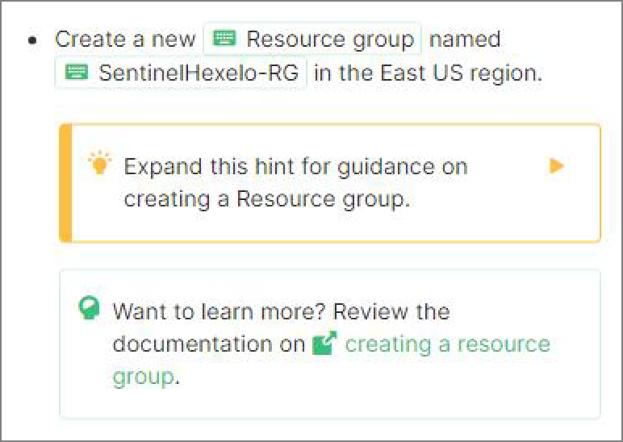

 **Expand this hint for guidance on creating an advanced hint.**



In Requirement #1, locate the Task #3 Guided Hint, select the **Advanced** Hint placeholder just below it, and then press **Delete**.

Enter the Advanced Hint text from above.

In the Learner Preview window, review the Advanced Hint, and then verify that the Task #2 Advanced Hint looks like the following:

Create a Guided Hint for the fourth task of Requirement 1, by using the following:



:::**ShowGuided**(**ShowGuided**=**Yes**)

>[+hint] **Expand this** hint **for** guidance on creating a **Log Analytics Worksp**

>

>- **On** the **Resource** groups page, **select** \*\***SentinelHexelo**-RG**.

>

>- **On** the **SentinelHexelo**-RG overview page, **select** \*\***Create**\*\*.

>

>- **On** the **Azure Marketplace** page, **in Search** resources, services, **and** docs

>

>- **On** the **Log Analytics Workspace** page, **select** \*\***Create**\*\*.

>

>- **On** the **Create Log Analytics** workspace page, on the **Basics** tab, **select**

>

>- **In Instance** details, **in Name**, enter +++**SentinelHexelo**-LAW+++, **and then**

>

>- **Select Review** + create, verify that the **Log Analytics Workspace** has pa

>

>- **Once** deployment **is** complete, **select** \*\***Go** to resource**.

:::

 

 **Expand this hint for guidance on creating a guided hint.** 

Locate Task #4, press Enter twice, and then enter the Guided Hint text from above.

In the Learner Preview window, expand the Guided Hint icon, and then verify that the Task #4 Guided Hint looks like the following:

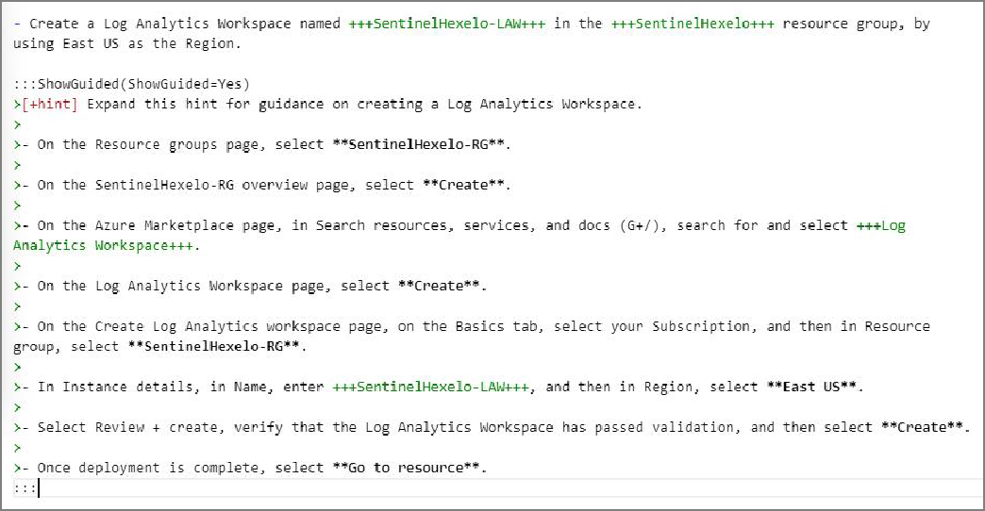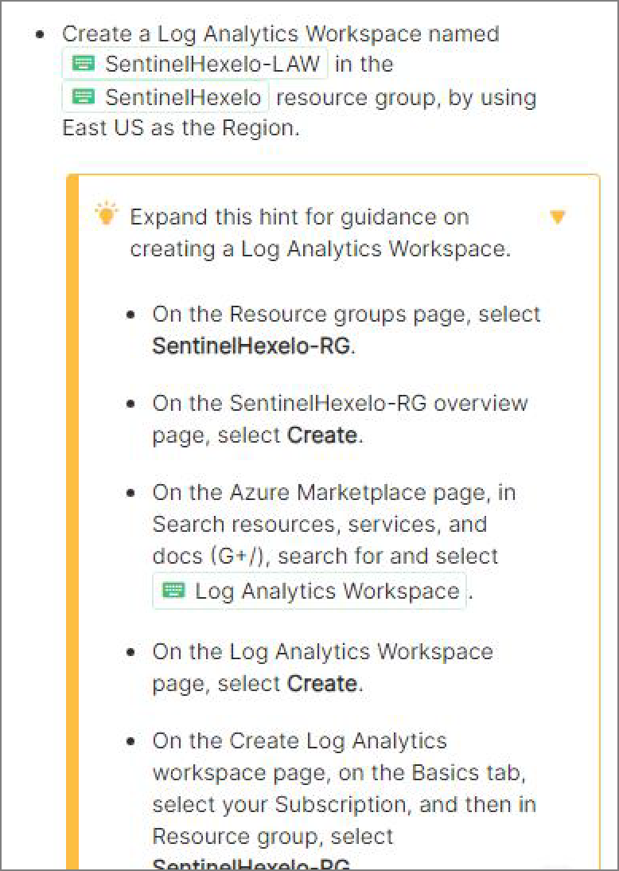

Create the Advanced Hint for the fourth Task of Requirement 1.



:::**ShowAdvanced**(**ShowAdvanced**=**Yes**)

>[!knowledge] **Want** to learn more? **Review** the documentation on [creating a

 

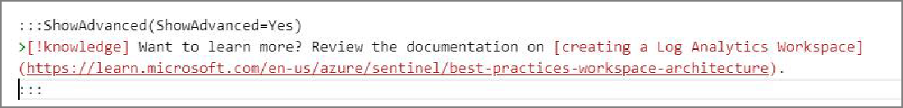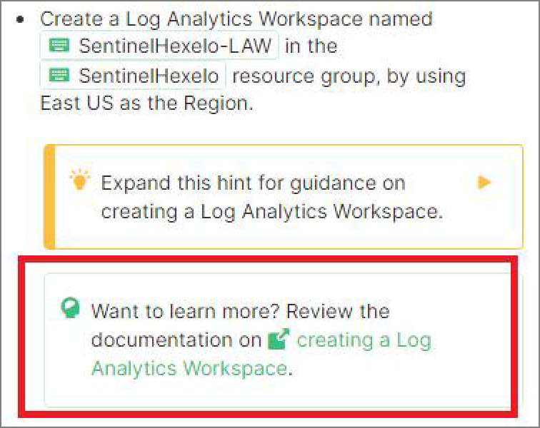

 **Expand this hint for guidance on creating an advanced hint.** 

In Requirement #1, locate the Task #4 Guided Hint, and then press **Enter** twice. Enter the Advanced Hint text from above.

In the Learner Preview window, review the Advanced Hint, and then verify that the Task #2 Advanced Hint looks like the following:

Create a Guided Hint for the fifth task of Requirement 1, by using the following:



:::**ShowGuided**(**ShowGuided**=**Yes**)

>[+hint] **Expand this** hint **for** guidance on adding **Microsoft Sentinel** to a

>

>- **On** the **SentinelHexelo**-LAW overview page, **in Search** resources, services

>

>- **On** the **Microsoft Sentinel** home page, **select** \*\***Create Microsoft Sentine**

>

>- **On** the **Add Microsoft Sentinel** to a workspace page, **in Workspace**, **selec**

>

>- **On** the **Microsoft Sentinel** free trial activated dialog, **select** **OK**.

:::

 

 **Expand this hint for guidance on creating a guided hint.** 

Locate Task #5, press Enter twice, and then enter the Guided Hint text from above.

In the Learner Preview window, expand the Guided Hint icon, and then verify that the Task #5 Guided Hint looks like the following:

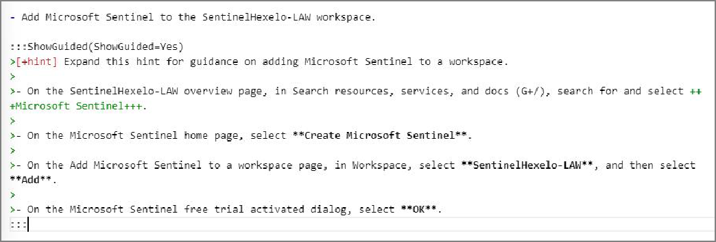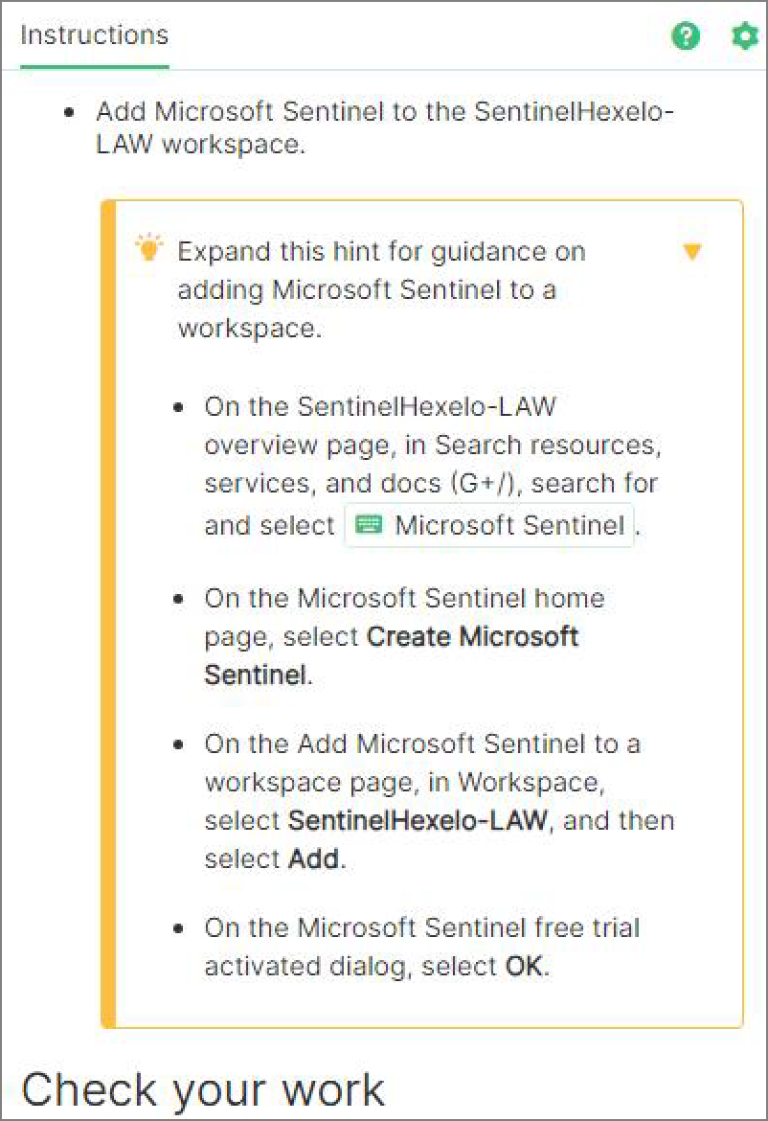

Create the Advanced Hint for the fifth Task of Requirement 1.



:::**ShowAdvanced**(**ShowAdvanced**=**Yes**)

>[!knowledge] **Want** to learn more? **Review** the documentation on [creating a

:::

 

 **Expand this hint for guidance on creating an advanced hint.**



In Requirement #1, locate the Task #5 Guided Hint, and then press **Enter** twice.

Enter the Advanced Hint text from above.

In the Learner Preview window, review the Advanced Hint, and then verify that the Task #2 Advanced Hint looks like the following:

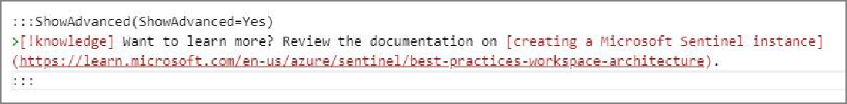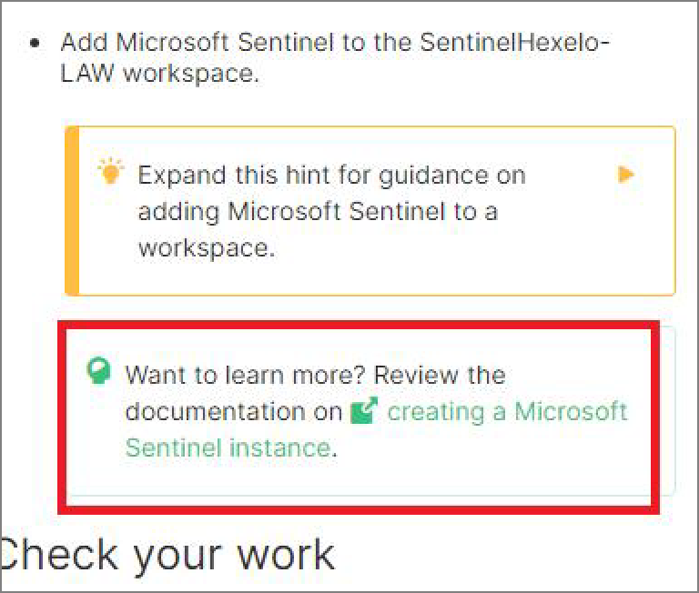

Check your work

Verify

# Create Notes, Alerts, and Help blocks



## Hints Enabled No Yes

Create a Note block for the first task of Requirement 1, instructing learners to T select the Type Text icon to enter the associated text into the virtual machine, and then convert the words T Type Text to TypeText by using the following:



>[!note] **Select** the +++**Type Text**+++ icon to enter the associated text **int**

 

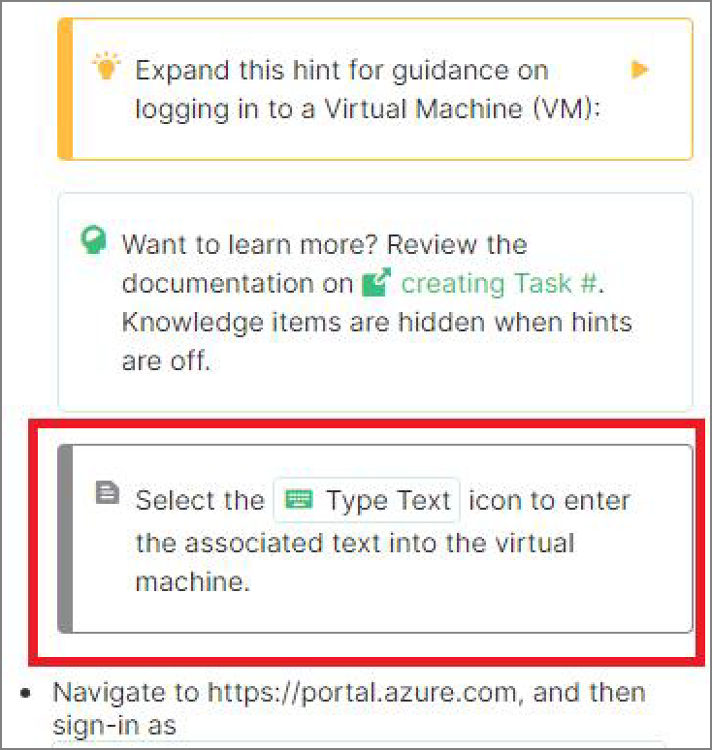

 **Expand this hint for guidance on creating a Note block.** 

Press **Ctrl+F** to open the **Find** dialog, and then enter T >[!help] Help items are useful.

Select the entire **Help Block** placeholder text, and then replace it with the Note block from above.

In the Learner Preview window, verify that the Task #1 Note block looks like the following:

 Want to learn more? Review the documentation on [creating a note block](https://portal.document360.io/a298db04-a0fe-47e0-bfe3-c52d6f9d7c8c/document/skillable-internal/view/0091347e-42c5-4b86-a4aa-09a8593052c4/).

 **Notes are typically used to call out something that be out of the ordinary in the lab** 

**environment, or that may not always be expected.**

Create a Note block for the third task of Requirement 1, informing learners that T a resource group is a logical container for creating your Azure resources by using the following:

 >[+note] A resource **group is** a logical container **for** creating your **Azure**

>

>**It** holds all your **Azure Resources**. A resource **group** created **in** a specifi

 

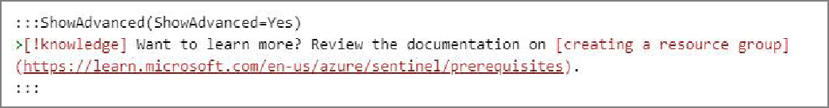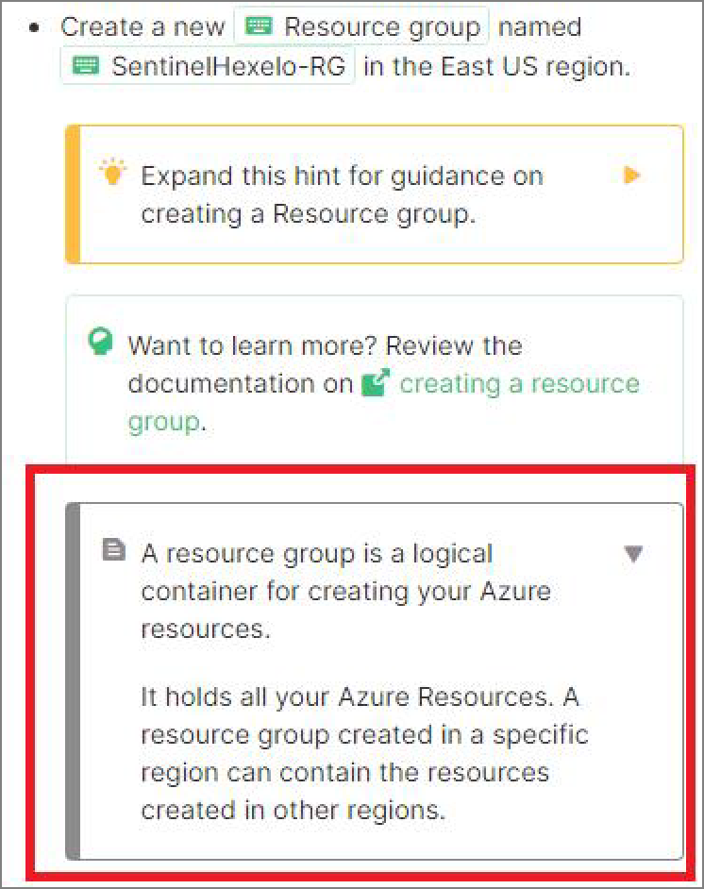

 **Expand this hint for guidance on creating a Note block.** 

Press **Ctrl+F** to open the **Find** dialog, and then enter T >[!note] Notes are a great for.

Select the entire **Note Block** placeholder text, replace it with the Note block from above, and then press **Enter**.

In the Learner Preview window, verify that the Task #3 Note block looks like the following:

Create an Alert block for the fourth task of Requirement 1, informing learners that T

deployment may take a few minutes, by using the following:

 >[!alert] **Deployment** may take a few minutes. **Select** \*\***Refresh**\*\* **if** the **ne**

 

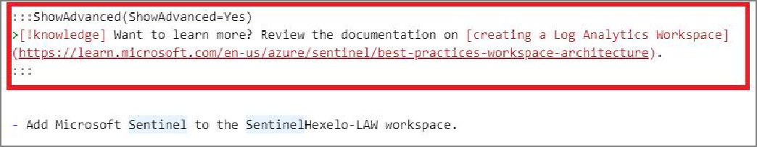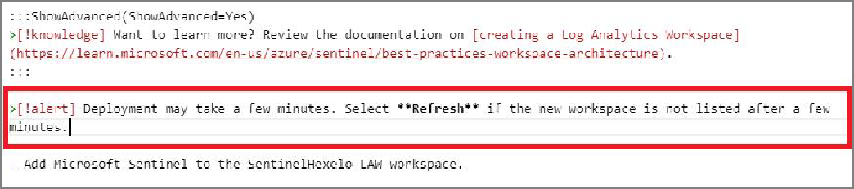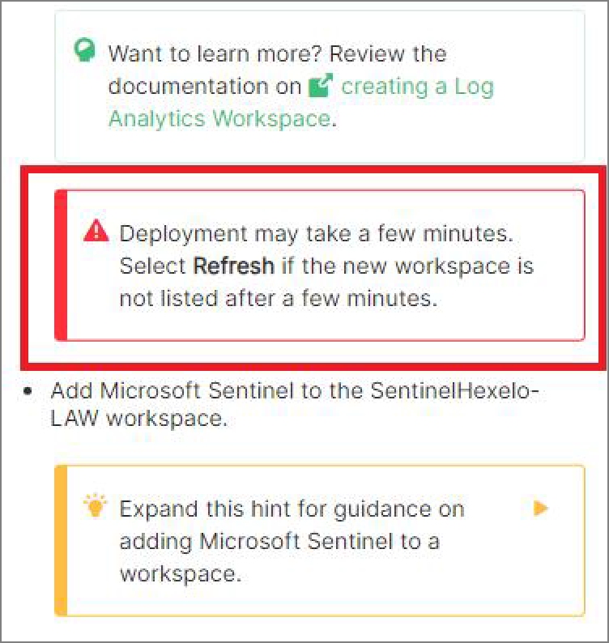

 **Expand this hint for guidance on creating an Alert block.** 

Press **Ctrl+F** to open the **Find** dialog, and then enter T Review the documentation on [creating a Log Analytics Workspace].

Place your cursor in the empty space between the Advanced hint and Task #5, and then enter the Alert block from above.

In the Learner Preview window, verify that the Task #4 Alert block looks like the following:

 Want to learn more? Review the documentation on [creating an alert block](https://portal.document360.io/a298db04-a0fe-47e0-bfe3-c52d6f9d7c8c/document/skillable-internal/view/7b43bdf6-6575-4151-8999-0bf1406fc066/).

 **Alerts should be used to grab the student's attention for something very important** 

**that they should not miss.**

Create a Help block for the fourth task of Requirement 1, by using the following:



>[!HELP] **An Azure Log Analytics Workspace is** a unique environment **for** log

>

>**Each** workspace has its own data repository **and** configuration but might c

 

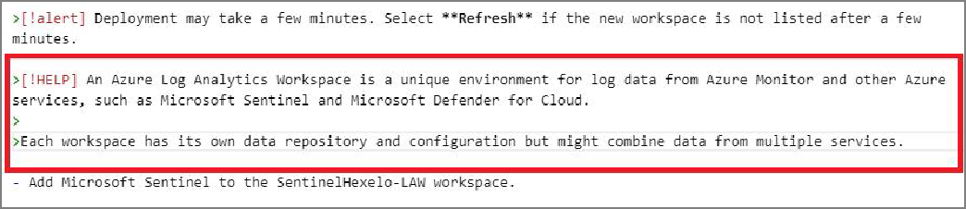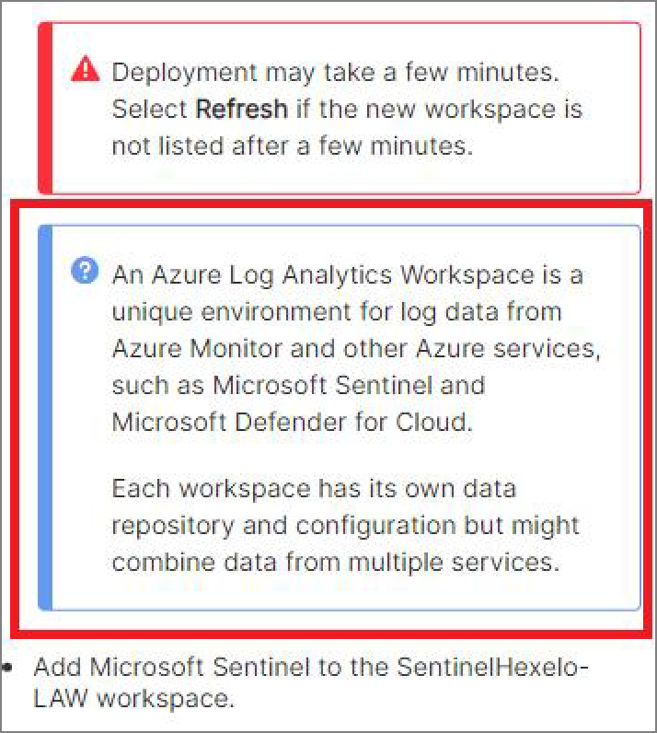

 **Expand this hint for guidance on creating a Help block.** 

Press **Ctrl+F** to open the **Find** dialog, and then enter T >[!alert] Deployment may take a few minutes.. *The alert you just created*

Place your cursor in the empty space between the Alert block and Task #5, and then enter the Help block from above.

In the Learner Preview window, verify that the Task #4 Help block looks like the following:

 **Help items are typically used to assist with something in the lab environment such as** 

**logons, switching VMs, etc.**

Create a Note block for the fifth task of Requirement 1, informing learners that T Microsoft Sentinel is a scalable, cloud-native Security Information and Event Management (SIEM) system by using the following:

 >[+note] **Microsoft Sentinel is** a scalable, cloud-**native Security Informat**

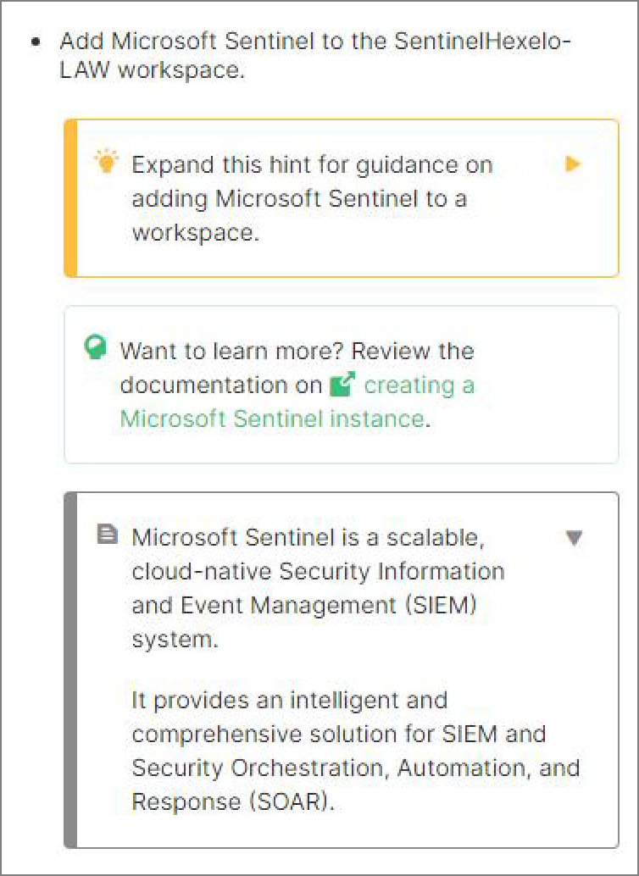

>

>**It** provides an intelligent **and** comprehensive solution **for** SIEM **and Secur**

 

Check your work

Verify

# Create the Summary Section



## Hints Enabled No Yes

Update the Challenge Lab name in the Summary.

 **Expand this hint for guidance on updating the Challenge Lab name in the Summary.** 

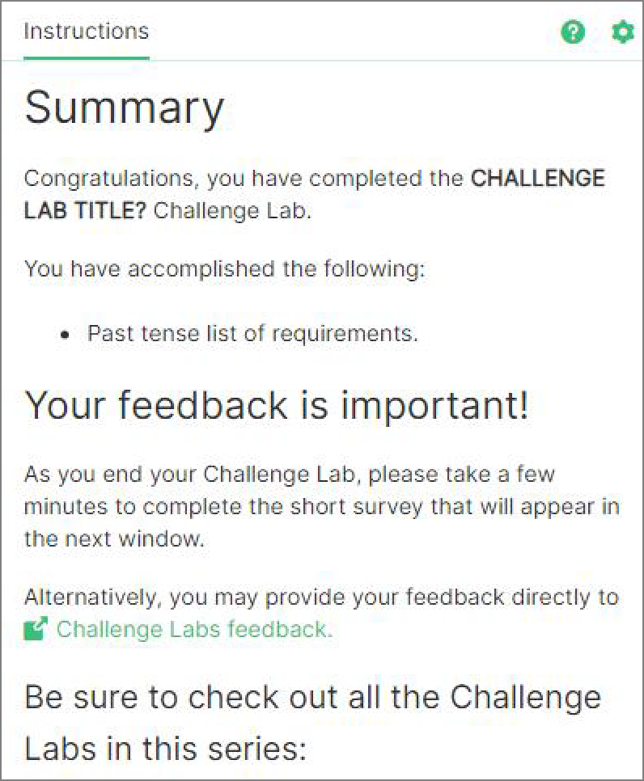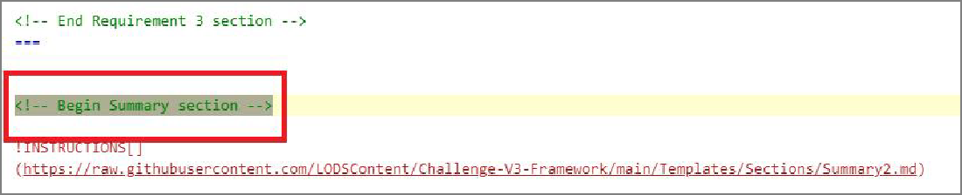

In the Learner Preview window, select **Next**, and then on the Enable a Data Connector page, select **Next** again.

On the Enable Threat Intelligence page, select **Next** to view the Summary page.

In the Markdown editor to the left, press **Ctrl+F** to open the **Find** dialog, and then enter T .

In Recap, select **CHALLENGE LAB TITLE?**, and then replace it with T Configure Threat Intelligence by Using Microsoft Sentinel.

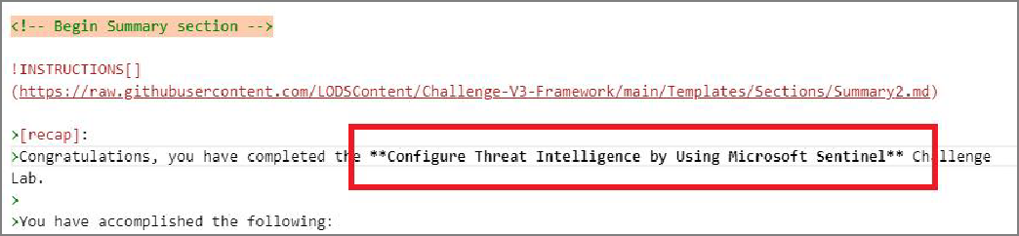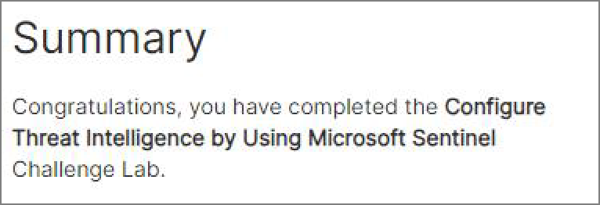

In the Learner Preview window, verify that the Task #4 Help block looks like the

following:

 Want to learn more? Review the documentation on [creating the summary section](https://portal.document360.io/a298db04-a0fe-47e0-bfe3-c52d6f9d7c8c/document/skillable-internal/view/077c082b-ee13-4e0a-83d5-3b3383a72e51/).

Update the Past list of requirements with each of the Requirements you created, and then convert them to past tense.

 **Expand this hint for guidance on updating the list of past requirements.** 

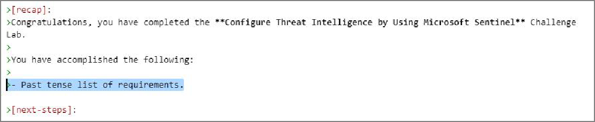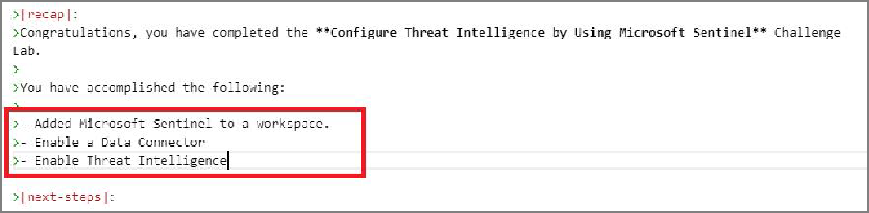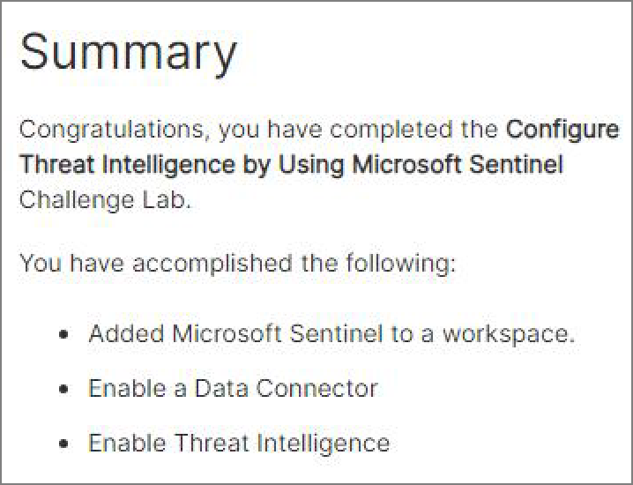

In the Markdown editor to the left, press **Ctrl+F** to open the **Find** dialog, and then enter T >- Past tense list of requirements..

Select **Past tense list of requirements**, replace it with T Added Microsoft Sentinel to a workspace., and then press **Enter**.

On the next line, type T >- Enable a Data Connector, and then press **Enter**. On the next line, type T >- Enable Threat Intelligence, and then press **Enter**

In the Learner Preview window, verify that the Summary looks like the following:

Verify

Check your work

# Add a scoring script



## Hints Enabled No Yes

Change the name of the **lab.Activity(requirement1)** Activity Group to match the name of Requirement #1.

 **Expand this hint for guidance on changing the name of an activity group.** 

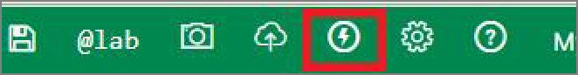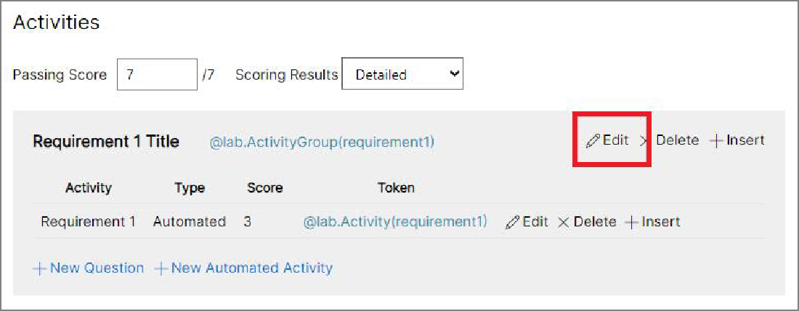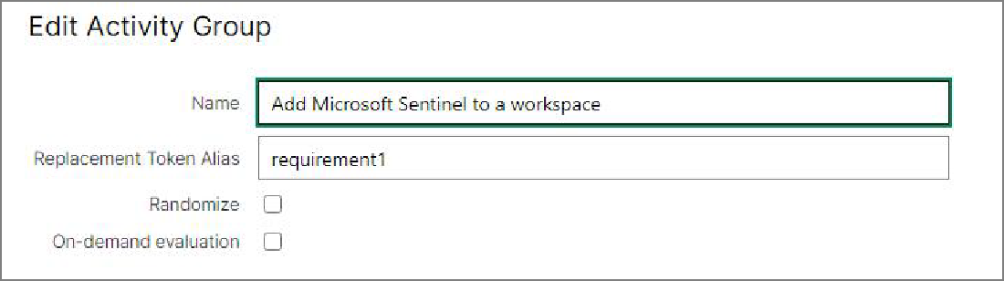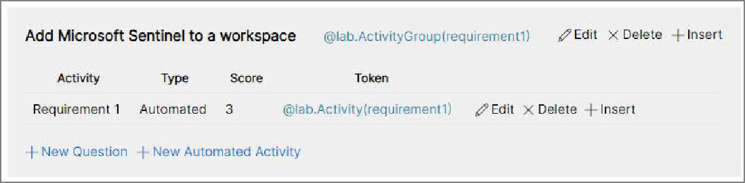

In the Markdown editor, on the Menu bar at the top of the screen, select the

**Lightning Bolt** icon.

In the **Requirement 1 Title** activity group, directly to the right of the lab token link, select **Edit**.

On the Edit Activity Group page, in Name, in Requirement 1 Title, type T Add Microsoft Sentinel to a workspace, and then press **Save**.

In the Activities window, verify that activity group #1 looks like the following:

 Want to learn more? Review the documentation on [adding scoring scripts](https://portal.document360.io/a298db04-a0fe-47e0-bfe3-c52d6f9d7c8c/document/skillable-internal/view/9cf7df36-8441-4bbf-be37-2e62255ab43c/).

Add a scoring script to the **Add Microsoft Sentinel to a workspace** requirement, by using the values in the following table.

|  |  |
| --- | --- |
| **Property** | **Value** |
| Name | T Add Microsoft Sentinel to a workspace |
| Replacement Token Alias | T Automated2 |
| Group | **Add Microsoft Sentinel to a workspace** |
| Scored | **Enabled** |
| Display Scripts as Task List | **Enabled** |
| Custom Evaluation Button Text | **Enabled** T Verify |
| Evaluation Button Placement | **Below Task List** |
| Allow retries | **Enabled** |
| Maximum Attempts | T 0 |
| Show Results in Reports | **Enabled** |

 **Expand this hint for guidance on adding a scoring script to an activity group.** 

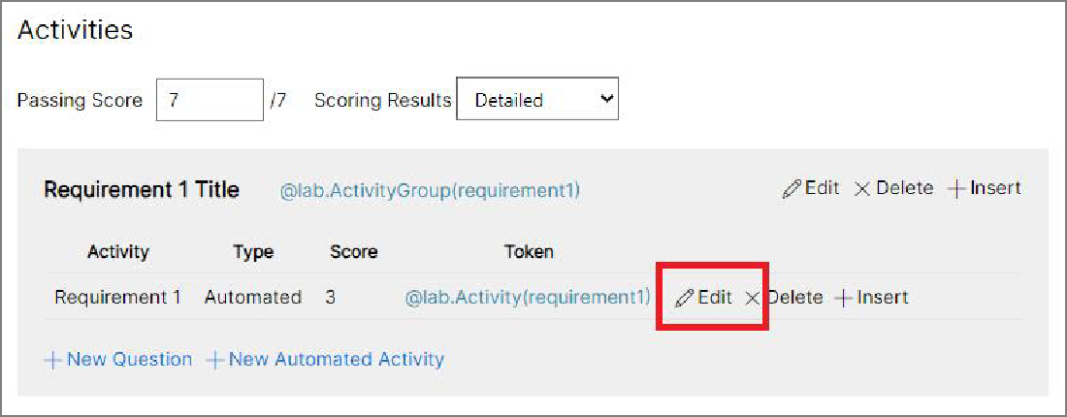

In the Activities window, in the Add Microsoft Sentinel to a workspace activity group, in the Activity section, locate Requirement 1, and then to the right of the token link, select **Edit**.

On the Edit Automated Activity page, in Name, type T Add Microsoft Sentinel to a workspace, and then in Group, verify that **Add Microsoft Sentinel to a workspace** is selected.

In Score, select the checkbox to enable it, and then in Display Scripts as Task List, select the checkbox to enable it.

In Custom Evaluation Button Text, select the checkbox to enable it, and then in the textbox to the right, enter T Verify.

In Evaluation Button Placement, select **Below Task List**, and then in Retries, select the checkbox to enable it.

In Maximum Attempts, enter T 0, and then in Show Results in Reports, select the checkbox to enable it.

In the Edit Automated Activity window, verify that activity #1 looks like the following:

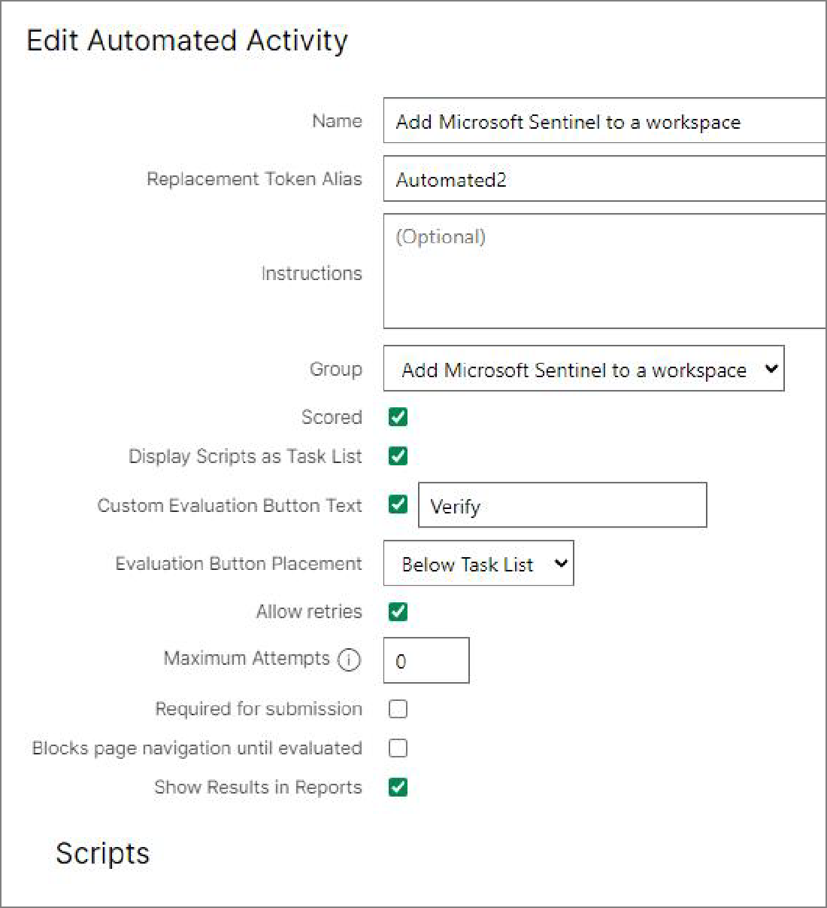

Edit the Script 1 **Task List Fields** by using the following:

***Text:*** T Verify that you have created a new resource group.

***Correct answer feedback:*** T Congratulations! You have successfully created a new resource group.

***Incorrect answer feedback:*** T You still need to create a new resource group.

 **Expand this hint for guidance on adding a scoring script to an activity group.** 

In Scripts, in Script 1, select the **Settings** tab.

In Task List Fields, in Text, enter T Verify that you have created a new resource group.

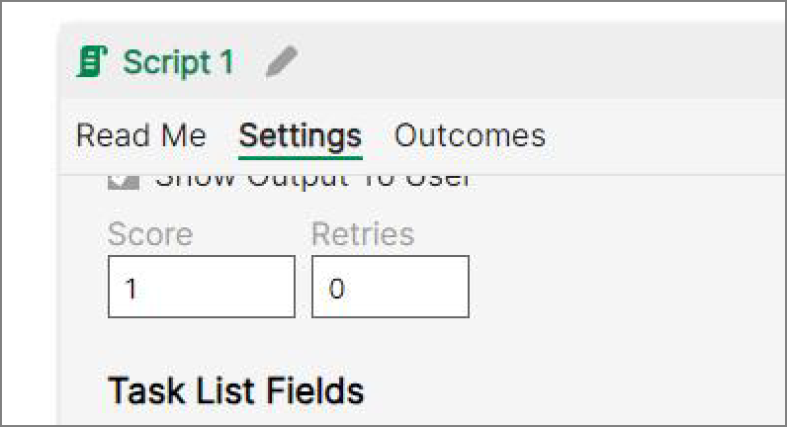

In Task List Fields, in Correct Answer Feedback, enter successfully created a new resource group.

T

In Task List Fields, in Incorrect Answer Feedback, enter new resource group.

T

Congratulations! You have You still need to create a

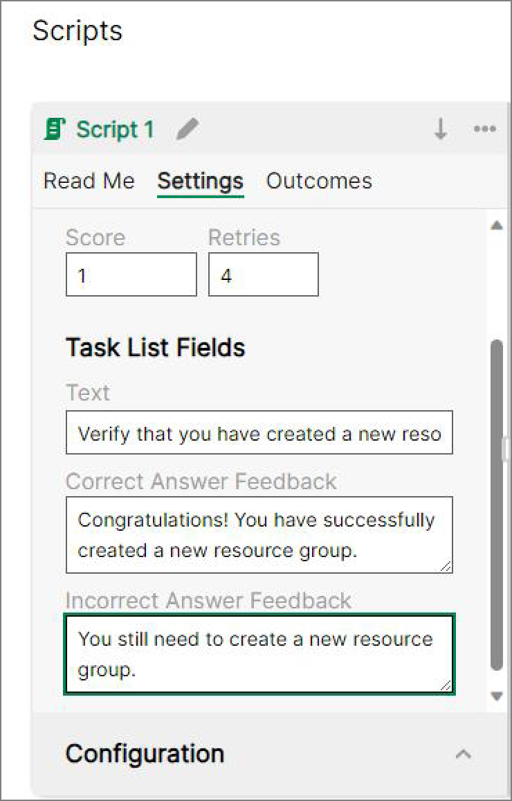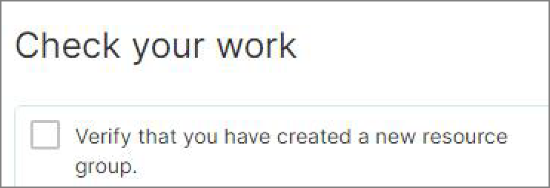

In the Learner Preview window, verify that the Check your work section looks like the following:

Replace the current script in Script 1 with the following supplied script:



*# Runs on Cloud Subscription PowerShell PS 7.4.0 | Az 11.1.0 (Release Can*

*## Set the $scriptDebug value to $true if needed. Default is $false.*

$scriptDebug = $false

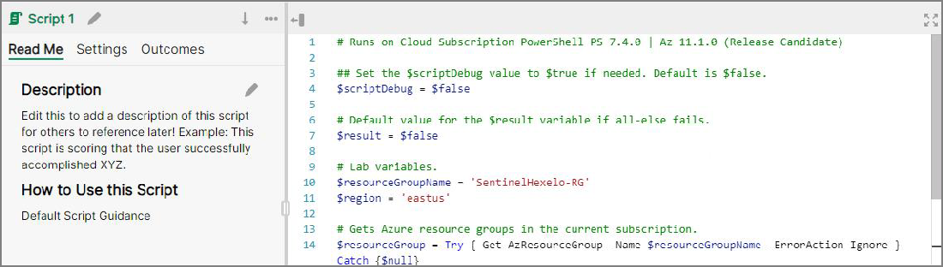

*# Default value for the $result variable if all-else fails.*

$result = $false

*# Lab variables.*

$resourceGroupName = 'SentinelHexelo-RG'

$region = 'eastus'

*# Gets Azure resource groups in the current subscription.*

$resourceGroup = **Try** { **Get**-**AzResourceGroup** -**Name** $resourceGroupName -**Erro**

*## This is an example of optional debug output for an individual command. ## command using the appropriate variable. This will only output if $scri* **If** ($scriptDebug) {**Write**-**Output** $resourceGroup | **Out**-**String**}

*# If this is true, then the user successfully created the resource group*

**If** ($resourceGroup -**and** $resourceGroup.**Location** -eq $region) {

$result = $true

} **Else** {

$result = $false

}

*# Using the Return keyword to return the True or False value.*

**Return** $result

 

 **Expand this hint for guidance on adding a scoring script to an activity group.**



In the Activities window, in the Add Microsoft Sentinel to a workspace activity group, in the Script window, select the current script, delete it, and then replace it with the script from above.

In the Edit Automated Activity window, verify that Script #1 looks like the following, and then press **Save**:

Add the Activity Group token to the Add Microsoft Sentinel to a workspace requirement.

 **Expand this hint for guidance on adding an activity group to the markdown.** 

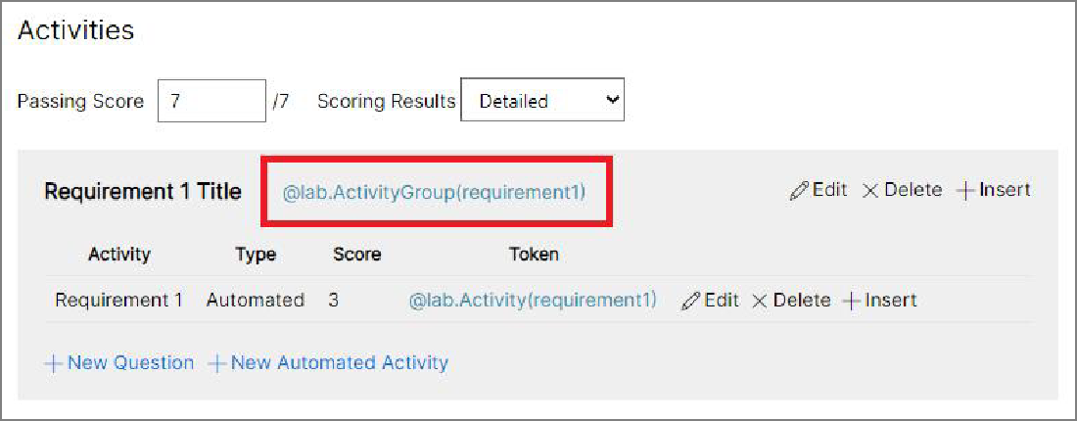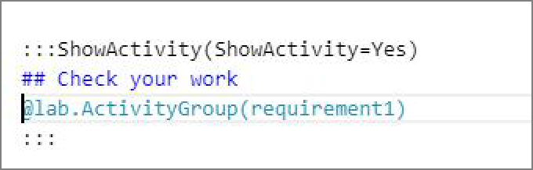

In the Activities window, in the **Add Microsoft Sentinel to a workspace** activity group, select and copy the **lab.ActivityGroup(requirement1)** lab token link.

Select **Close**, to close the Activities window.

In the Markdown editor to the left, press **Ctrl+F** to open the **Find** dialog, and then enter T lab.ActivityGroup(requirement1).

Replace the current Activity Group token with the one you just copied. Verify that the Check your work section looks like the following:

 Want to learn more? Review the documentation on [check your work](https://portal.document360.io/a298db04-a0fe-47e0-bfe3-c52d6f9d7c8c/document/skillable-internal/view/1f78298a-34e1-409e-88f8-720cb6d5764a/).

Check your work

Verify

# Run the new Challenge Lab



## Hints Enabled No Yes

Remove the **Sample Markdown Elements - Remove this section for production** section from the Challenge Lab.

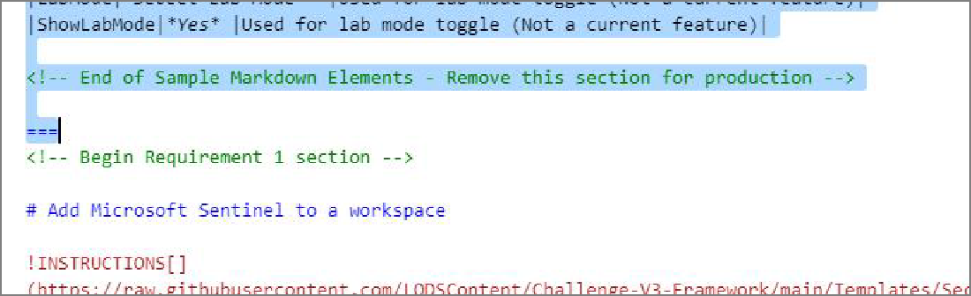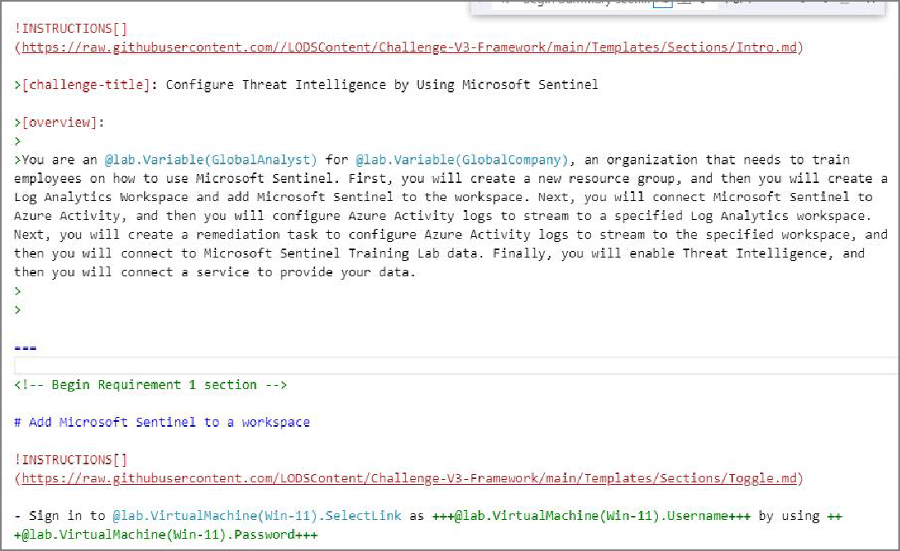

 **Expand this hint for guidance on removing the Sample Markdown Elements section.** 

In the Markdown editor to the left, press **Ctrl+F** to open the **Find** dialog, and then enter T Sample Markdown Elements - Remove this section for production.

Press **Delete**.

Run the **Configure Threat Intelligence by Using Microsoft Sentinel** Challenge Lab.

 **Expand this hint for guidance on running a Challenge Lab.**



Select the **Back** button on your browser to return to the Lab Profile page.

On the Lab Profile page, select **Launch**.

:::ShowActivity(ShowActivity=Yes)

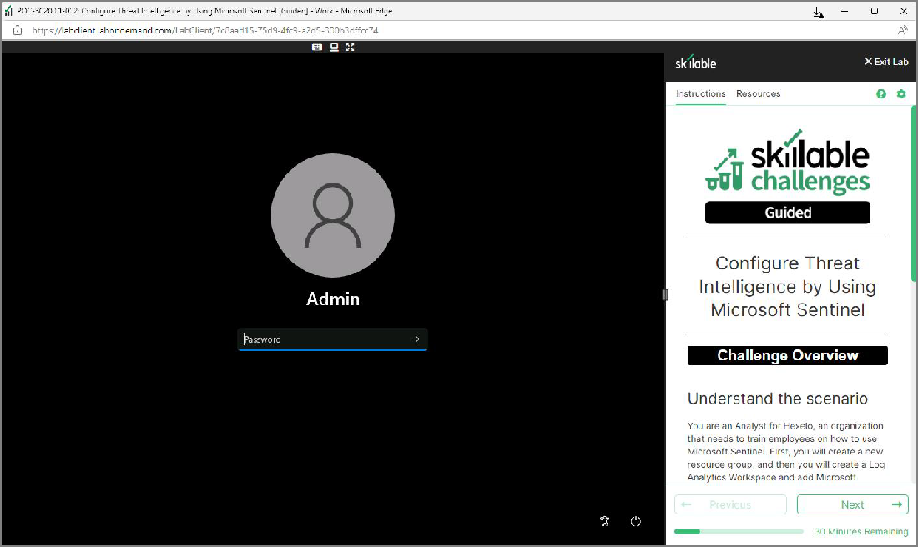

Check your work

Verify

# Summary

Congratulations, you have completed the **Create a Challenge Lab** Challenge Lab. You have accomplished the following:

Cloned a Challenge Lab template. Created the Title and Overview.

Created 3 sets of Requirements.

Created the tasks for each set of Requirements.

Created Guided and Advanced Hints for the Tasks in Requirement 1. Created a Summary page.

Added a scoring script.

Launched your new Challenge Lab.

Ending your lab

To ensure your lab is recorded as complete, select **Submit** or **End** below. Exiting [X] the lab will result in an incomplete status.

 Once you select **Submit** or **End**, you will not be able to return to this Challenge Lab.

Your feedback is important!

As you end your Challenge Lab, please take a few minutes to complete the short survey that will appear in the next window. Alternatively, you may provide your feedback directly to [Challenge Labs feedback.](https://supportrequest.learnondemandsystems.com/sf.php?s=123formbuilder-5553155&control66068515=%7BEMAIL%7D&control111000309=%7BLAB_INSTANCE_ID%7D&control111000314=173208&control66068513=%7BUSER_FIRSTNAME%7D&control66068514=%7BUSER_LASTNAME%7D&control66068517=%7BUSER_ORGANIZATION_NAME%7D)

Looking for your next Challenge Lab?

Below are recommended Challenge Labs to try next.